**LAB1:** (6-1-2024)

A. perform read/write operations on a file

B. Find the number of characters in a file

C. Find a specific file word and replace it with other word in the complete file

**Code-**

1. **perform read/write operations on a file.**

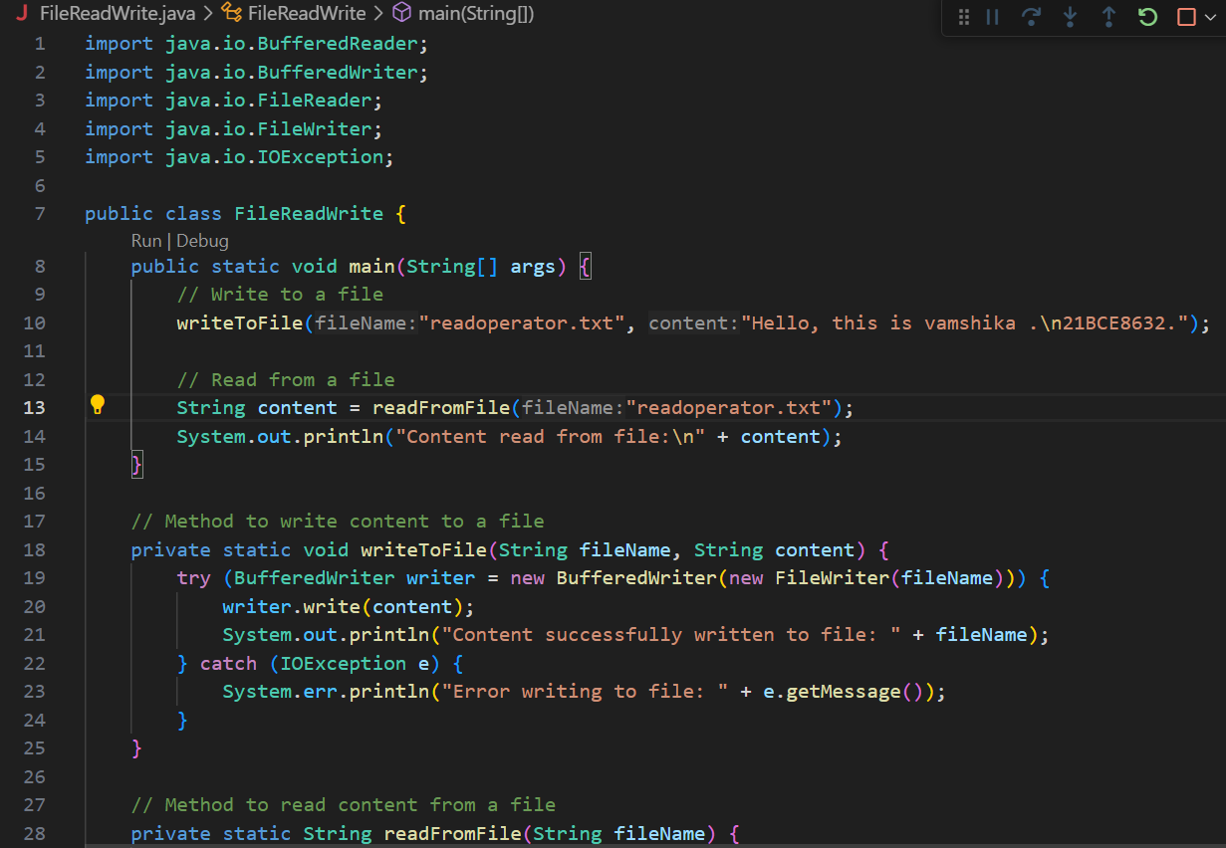

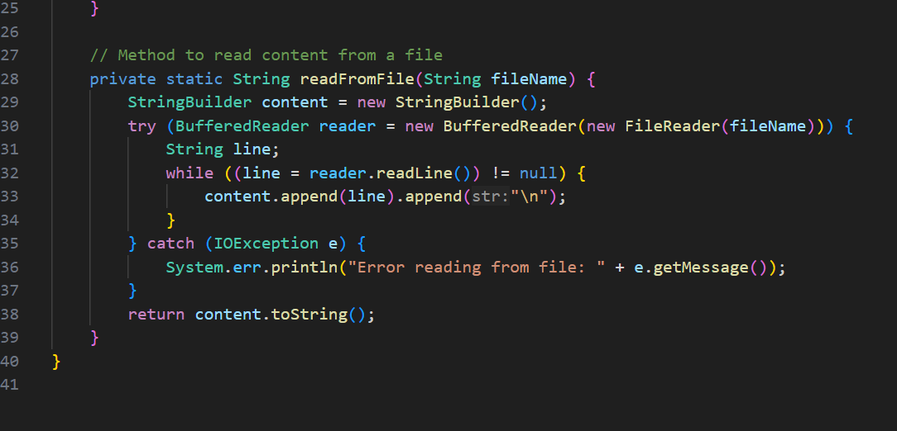

**Output-**

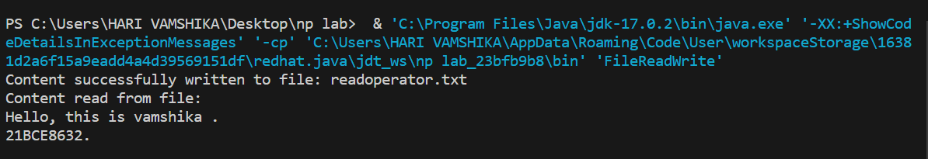

**b)** **Find the number of characters in a file.**

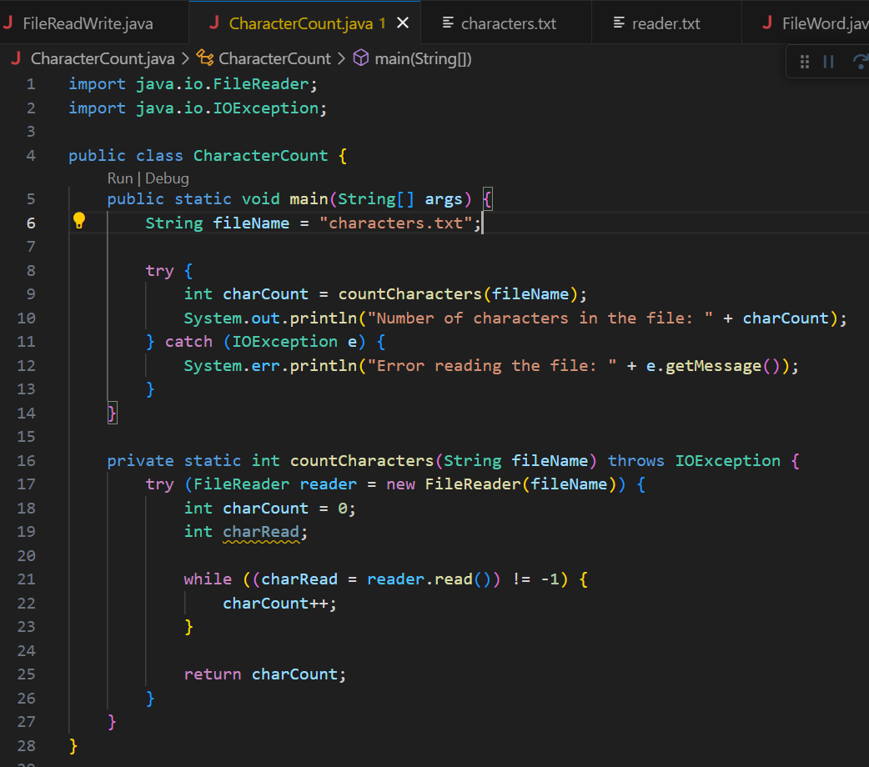

**Output-**

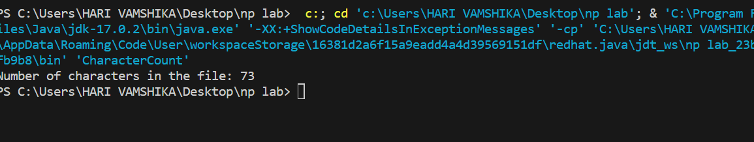

**c)** **Find a specific file word and replace it with other word in the complete file.**

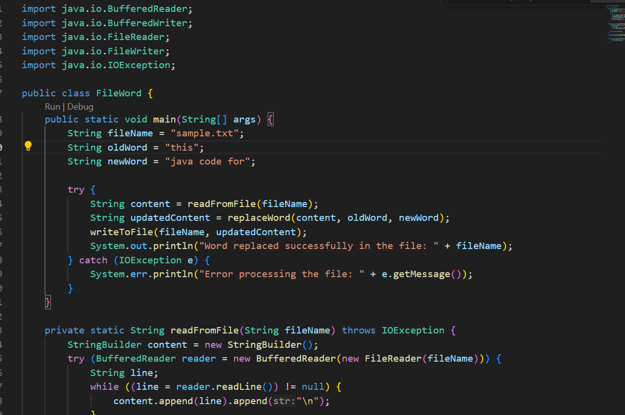

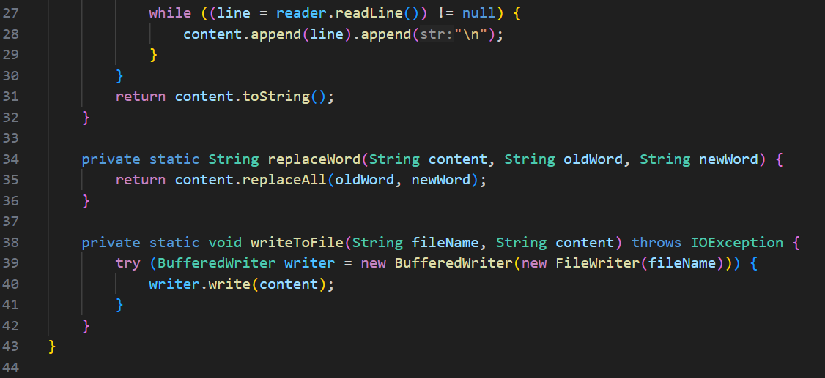

**Output-**

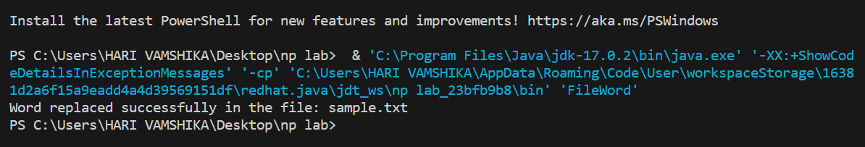

**Before text file contents-**

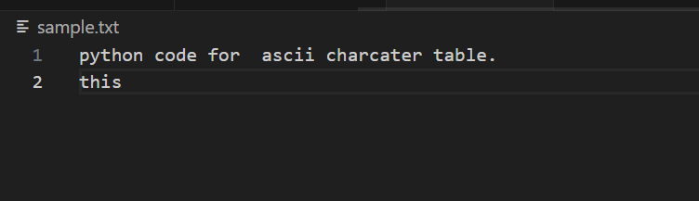

**After execution text file contents-**

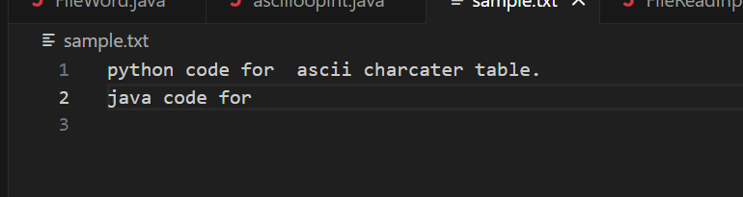

**LAB2:** (20-1-2024)

A. Use OutputStream class to perform write operations using write(int) method to solve the following problem

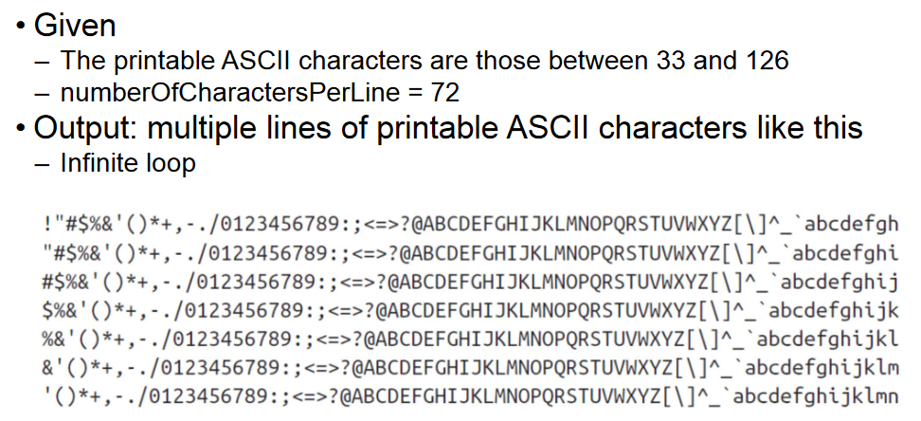

B. Solve the above problem using write(byte[]) method

C. Find the execution time difference between program A and Program B

**Code-**

1. **Use Output Stream class to perform write operations using write(int) method to solve the following problem.**

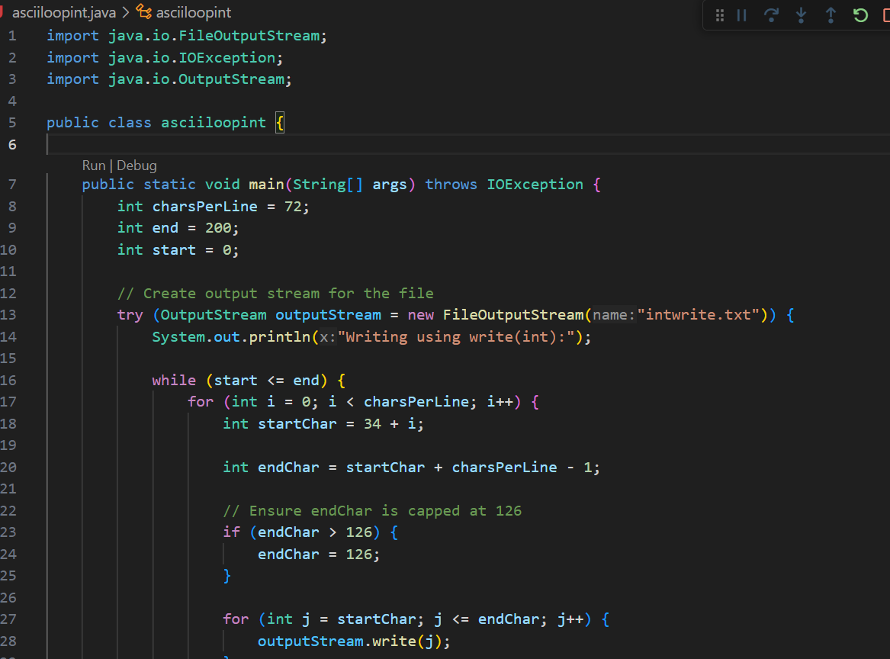

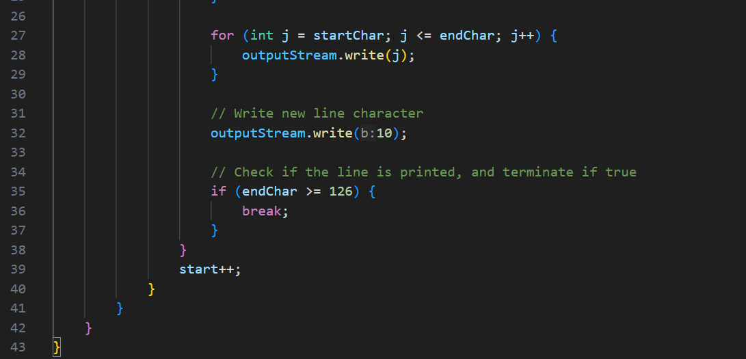

**Output-**

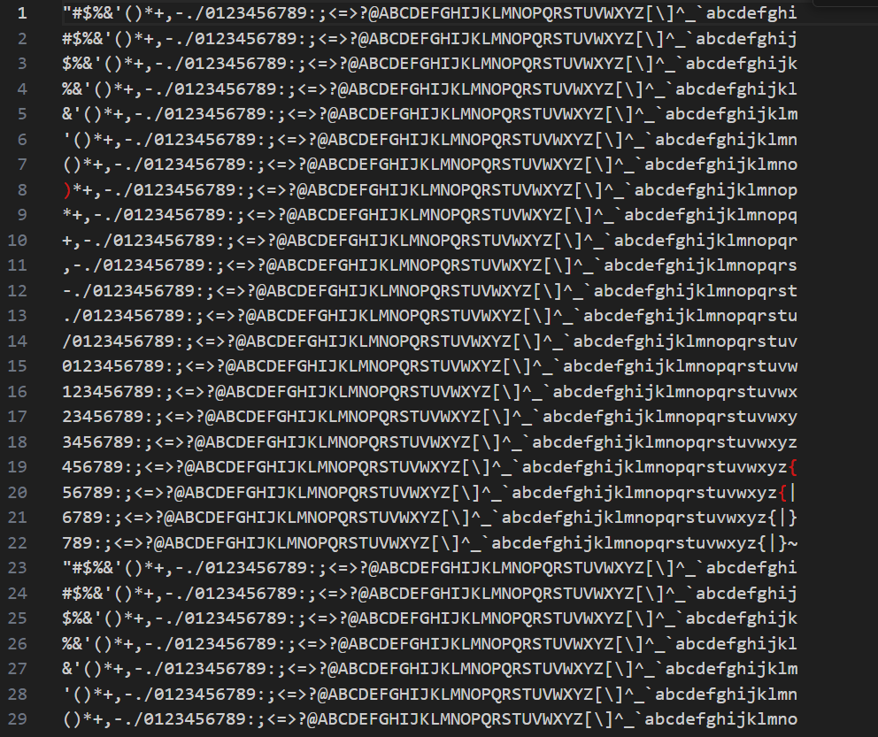

1. **Solve the above problem using write(byte[]) method.**

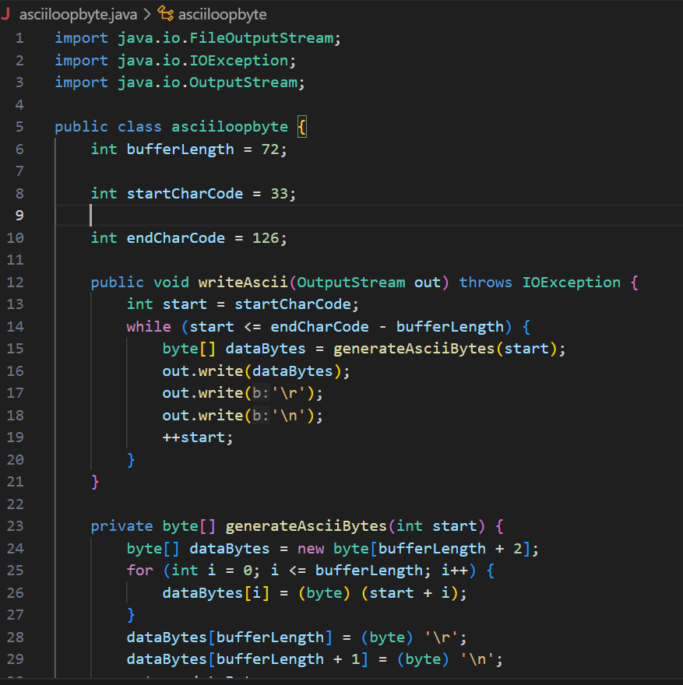

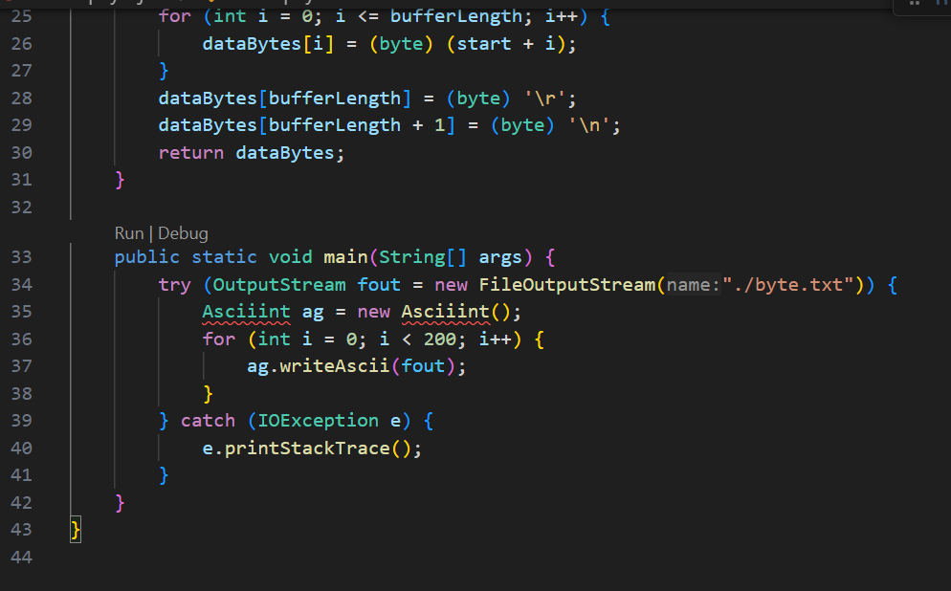

**Output-**

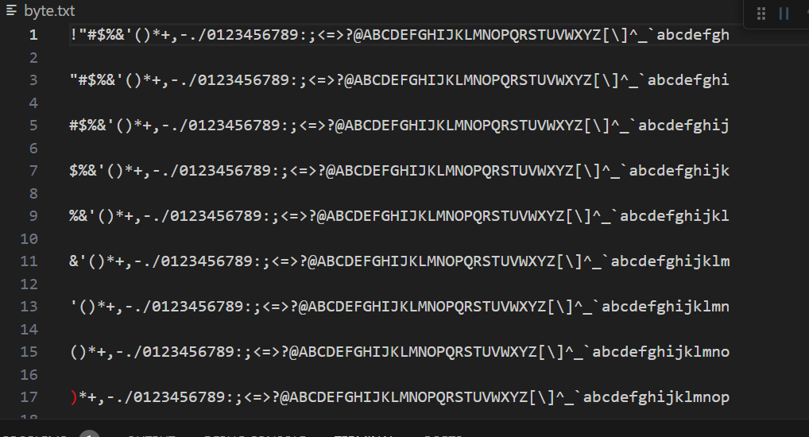

1. **Find the execution time difference between program A and Program B.**

**Int-**

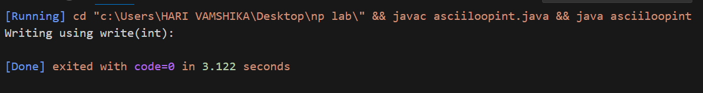

**Byte-**

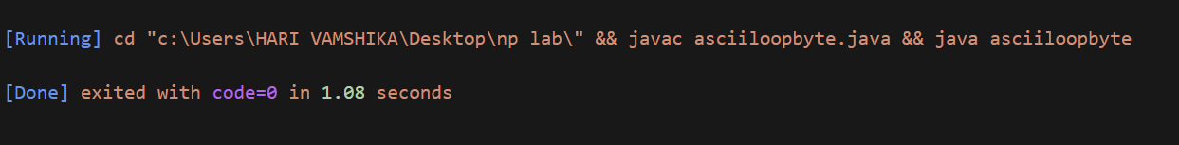

**LAB3:** (22-01-2024)

**2. Use the InputStream class to solve the following problem**

1. **Read the characters from a file using read() method**

**CODE-**

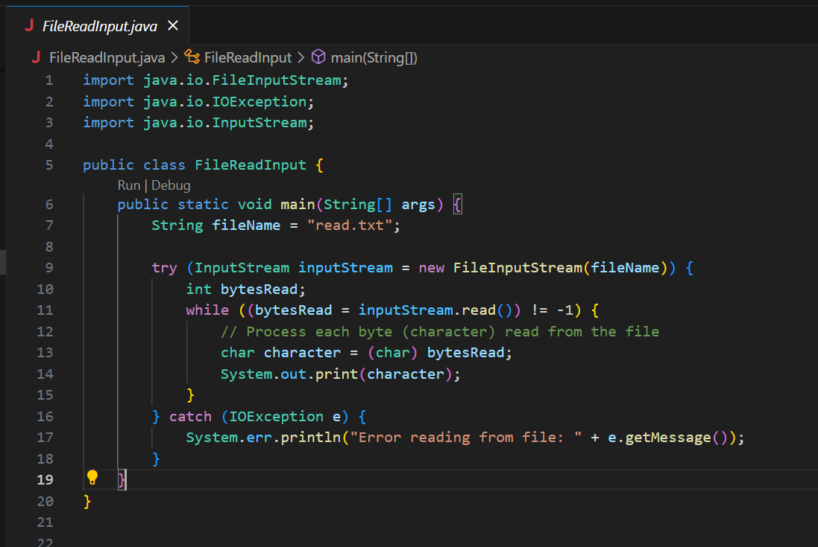

**OUTPUT-**

1. **Read the characters from a file using read(byte[]), read(byte[],offset,length)**

**CODE-**

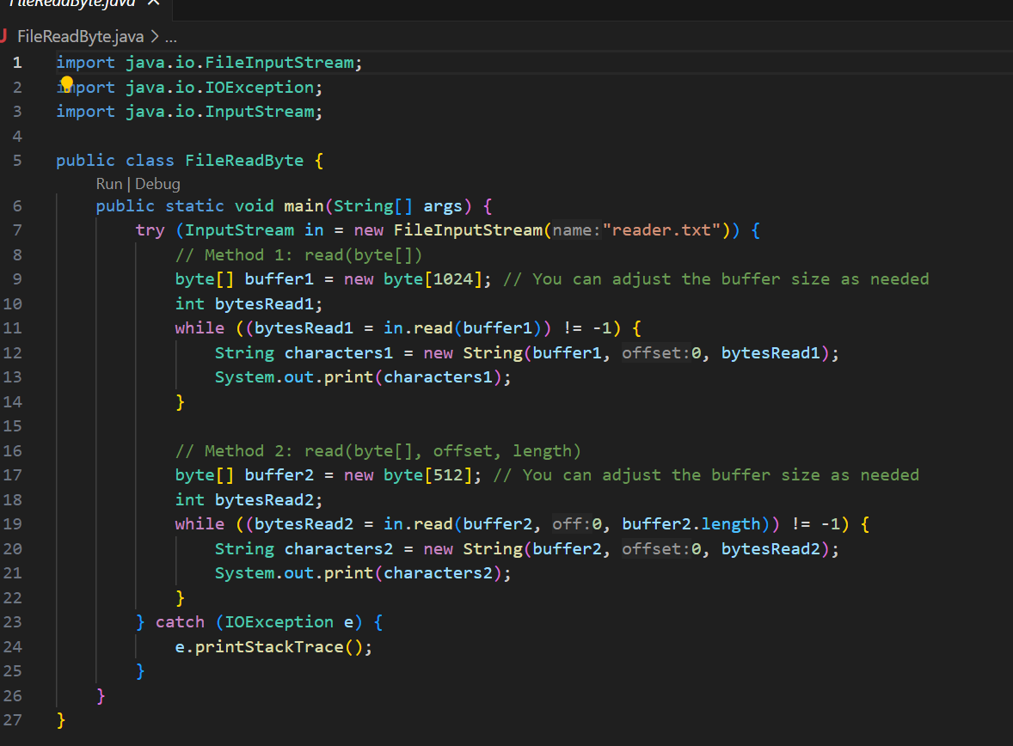

**OUTPUT-**

1. **Ignore first 100 characters from the file in the read operation**

**CODE-**

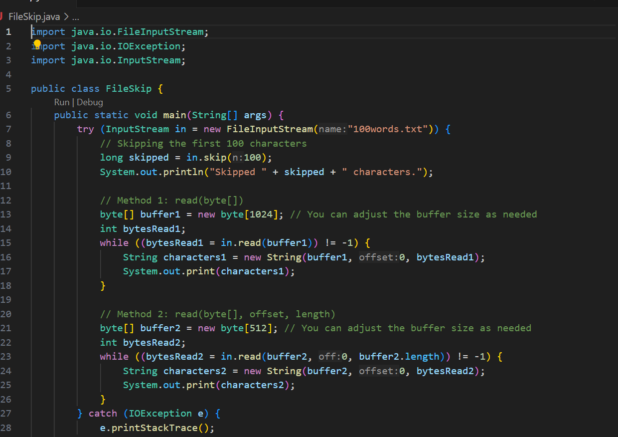

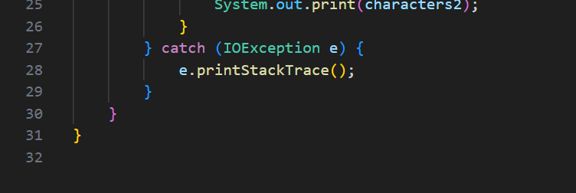

**OUTPUT-**

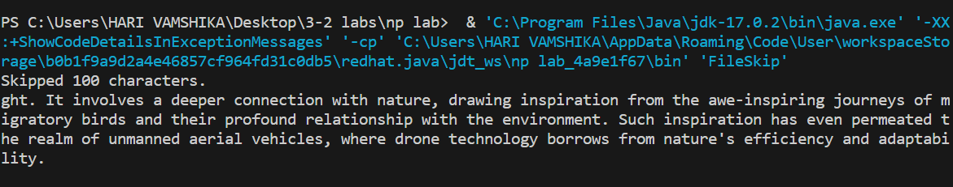

**d .How the available() method is used in file read operations**

**CODE-**

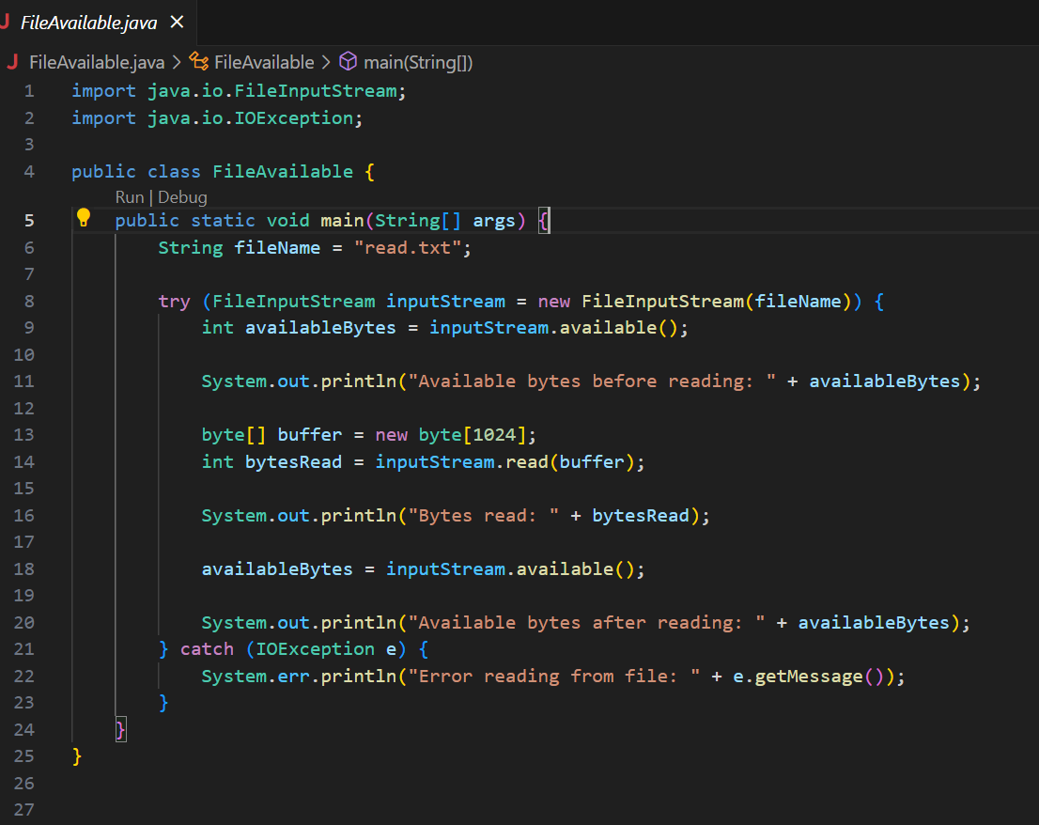

**OUTPUT-**

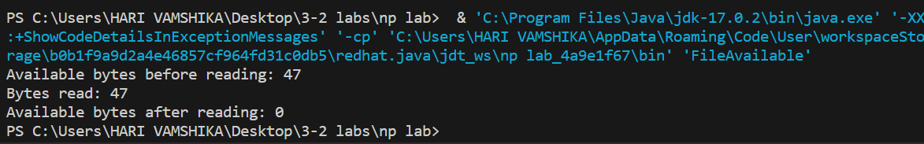

1. **Print 10 to 30 characters repeatedly 10 times using mark() and reset() method**

**CODE-**

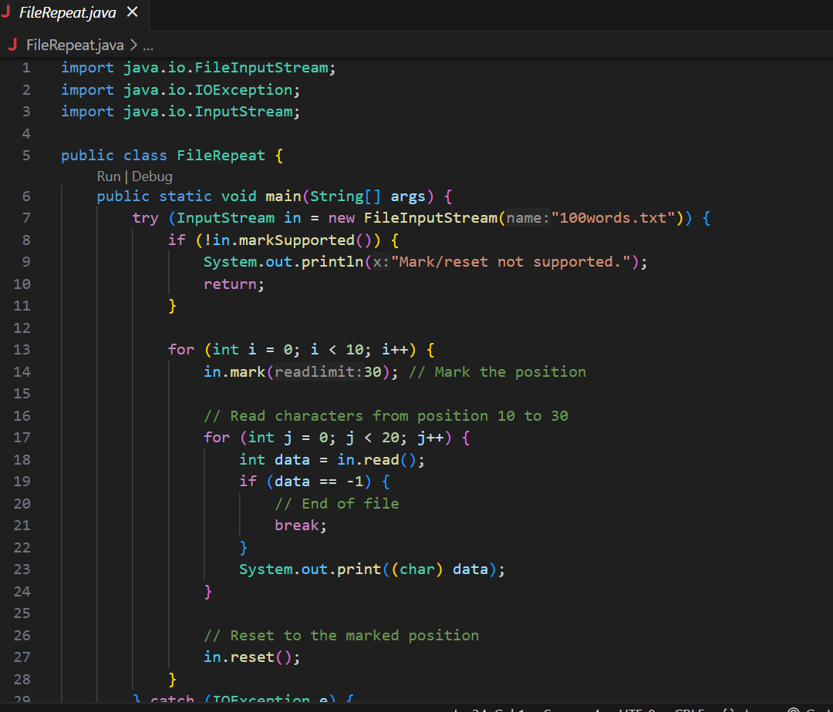

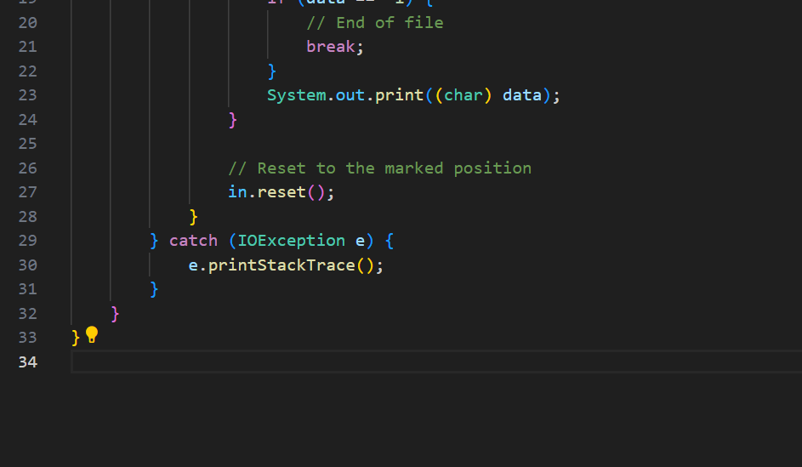

**OUTPUT-**

**LAB4:(27-01-2024)**

1. **Using the InputStream class, John has to read the first five characters then Tom has to read the rest of the five characters from a shared source file using the multi thread concept. In this context, assist John and Tom in writing java code. Example(test.txt contains “associated” John- assoc Tom:-iated )**

**CODE-**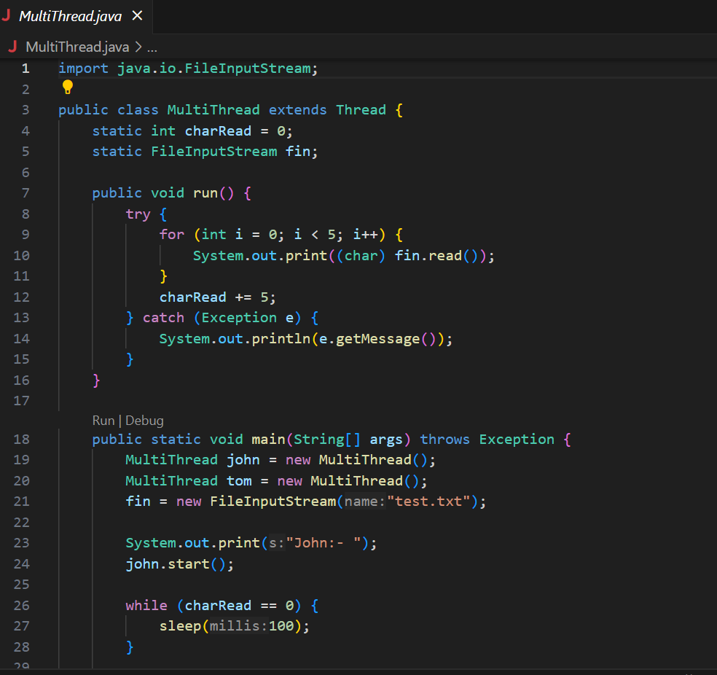

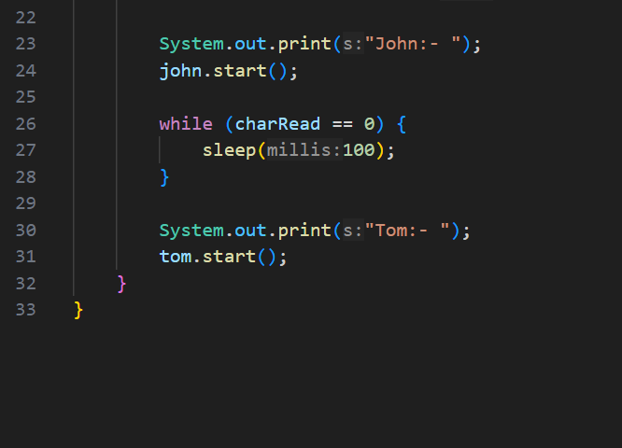

**OUTPUT-**

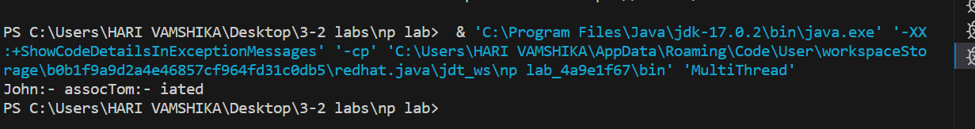

1. **Assume that you have a file1.txt that contain 100 characters, write a program to read 10 to 50 range characters five times and write these characters in the file2.txt.**

**CODE-**

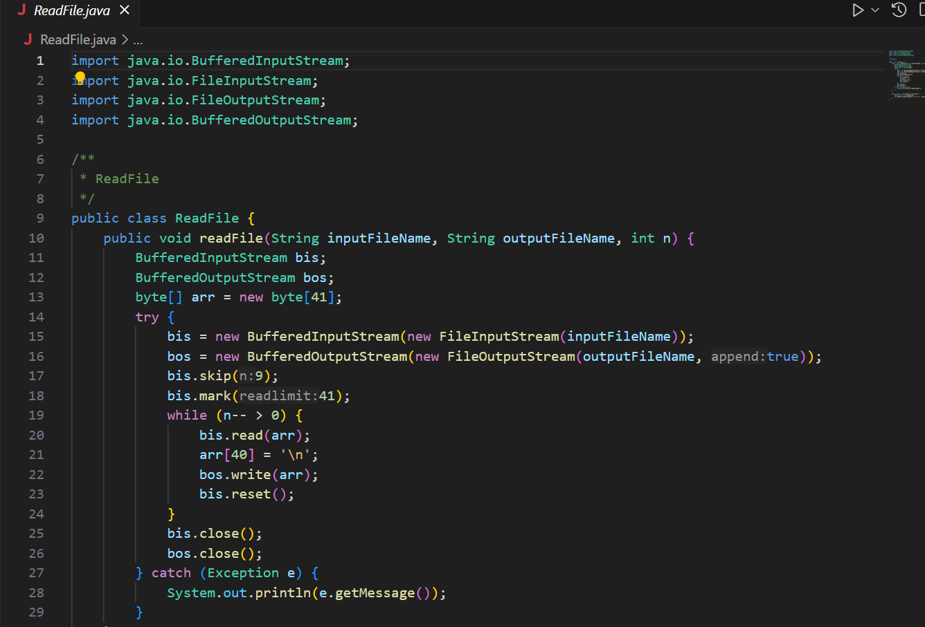

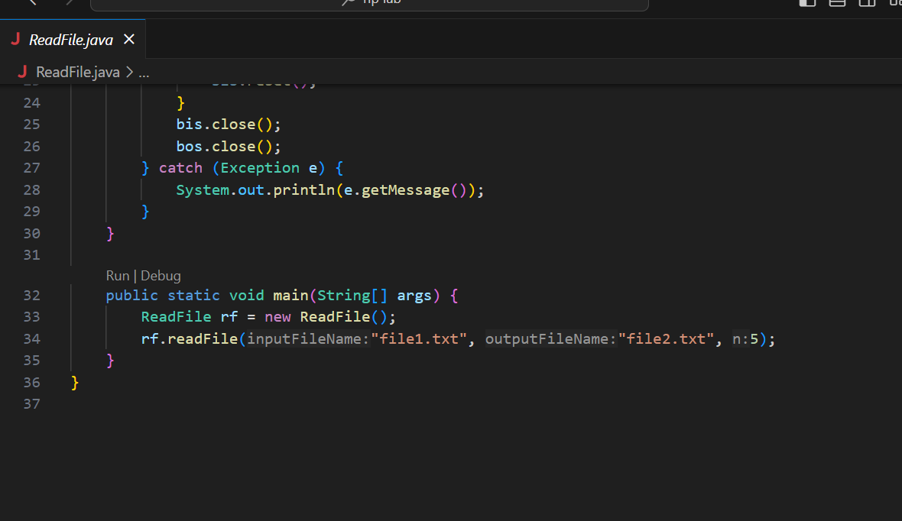

**OUTPUT-**

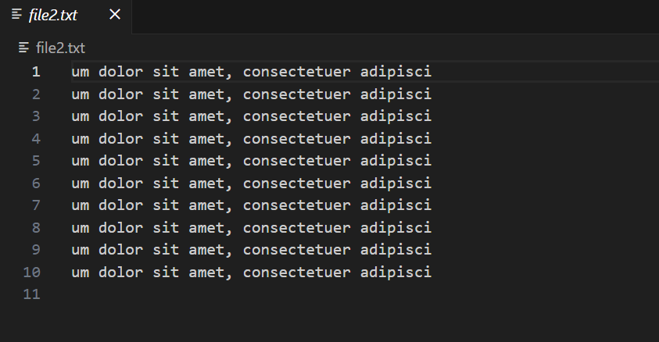

1. **Write a java codes to write the following sequence data into the destination file using Write class and OutputStream Concept.**

**0123456**

**1234567**

**2345678**

**3456789**

**Do the runtime analysis of these programs.**

**CODE-**

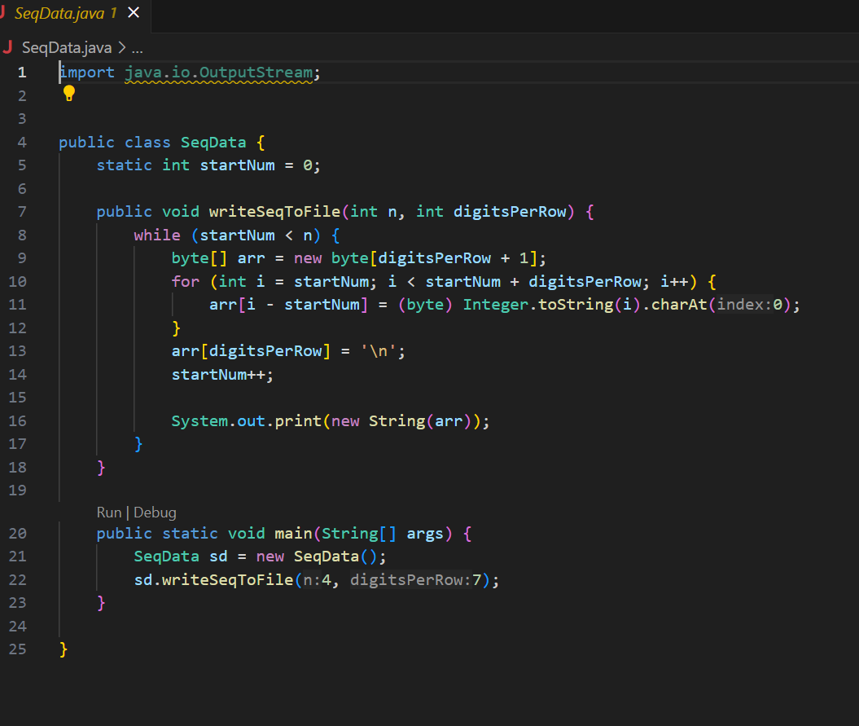

**OUTPUT-**

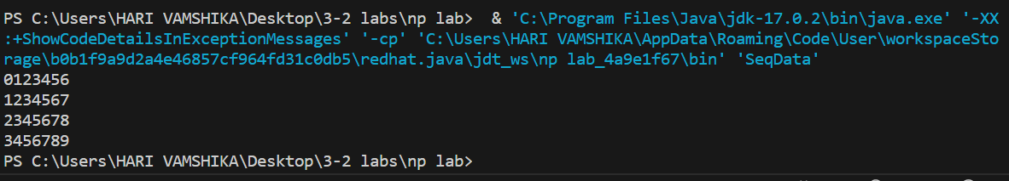

**LAB-5 (3-2-2024)**

1. **Explore all uri class methods and url class methods**

**CODE-**

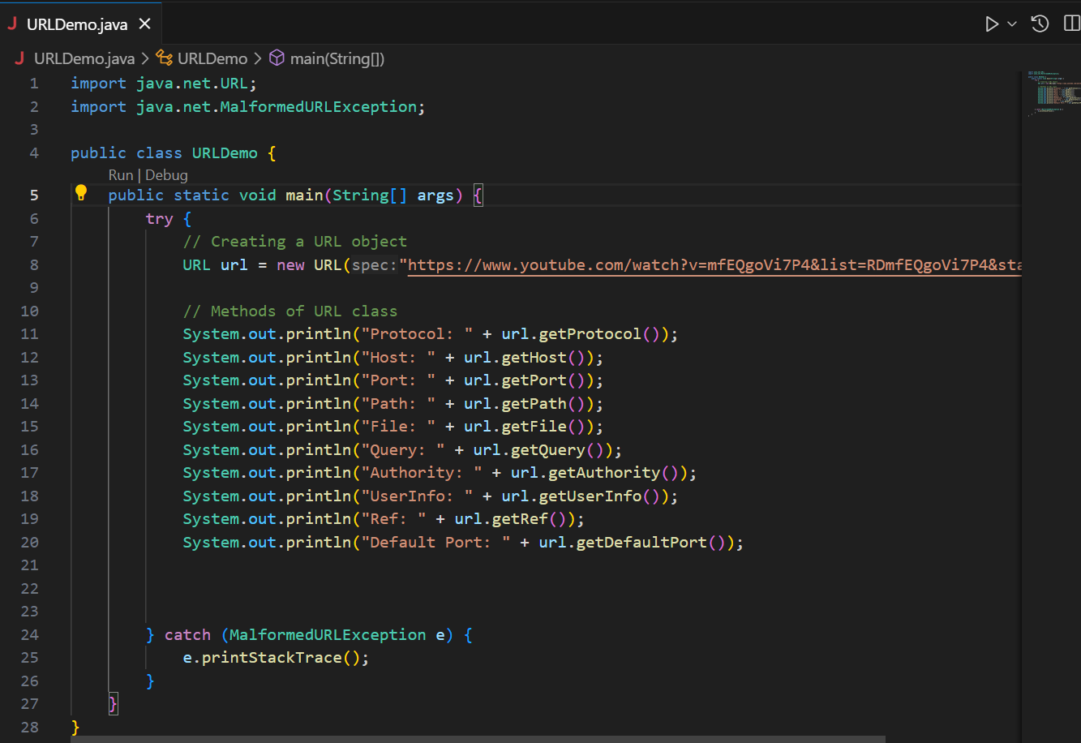

**OUTPUT-**

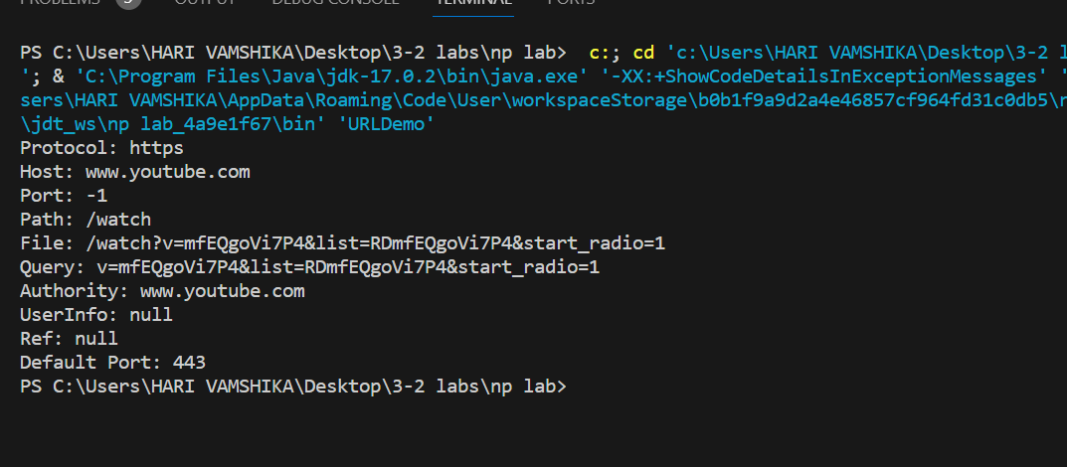

1. **Convert url to uri**

**CODE-**

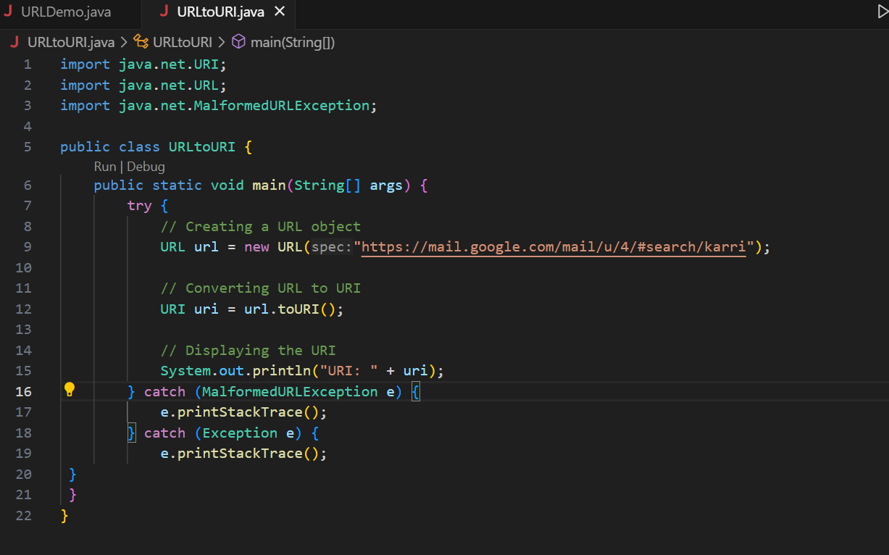

**OUTPUT-**

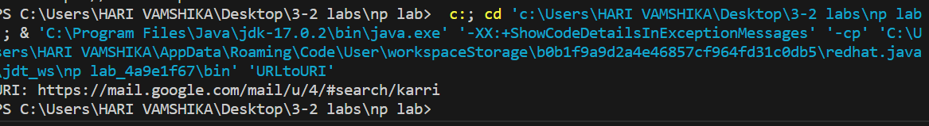

1. **Find the network interfaces which are assigned to 192.168.1.1 to 192.168.1.150 address range.**

**CODE-**

1. **Explore all NetworkInterface class  methods**

**CODE-**

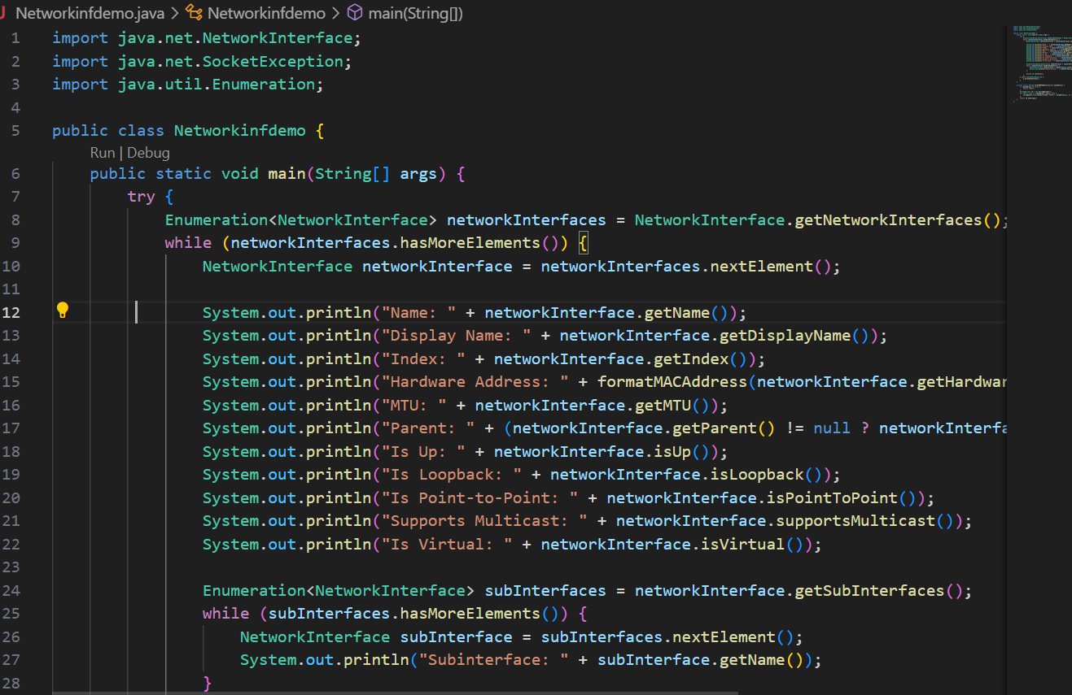

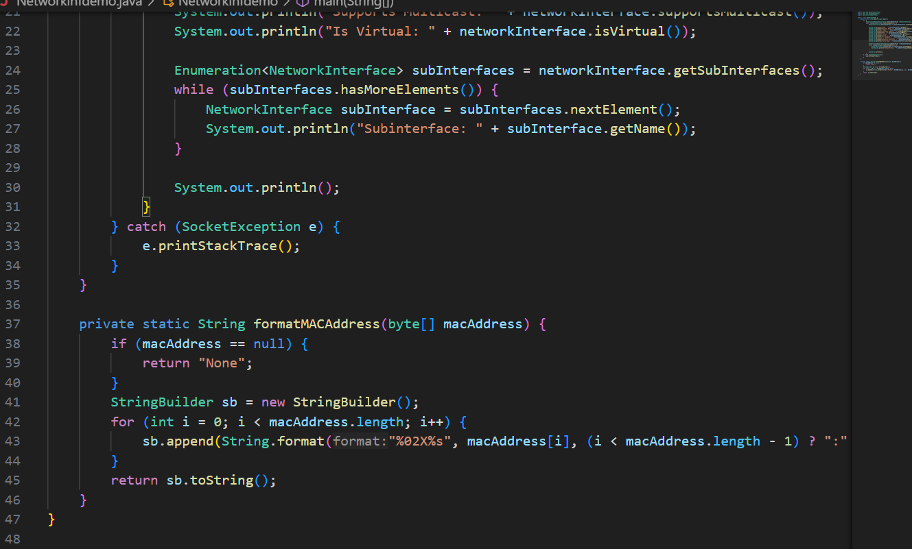

**OUTPUT-**

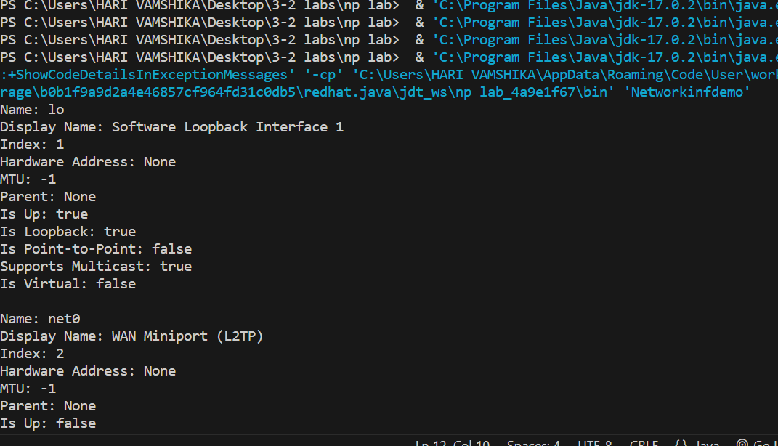

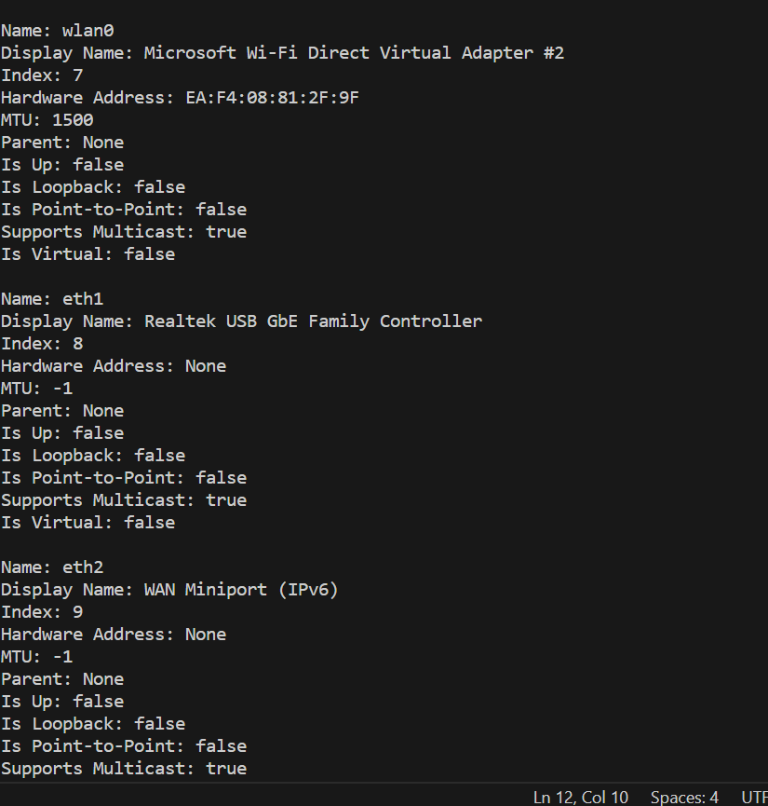

**LAB-6(17-02-2024)**

**A. Use the following URL connection Class to connect to the web pages,**

**•Use only InputStream class (openStream())**

**•Use URLConnection class (openConnection())**

**Write the advantage and disadvantage of each class**

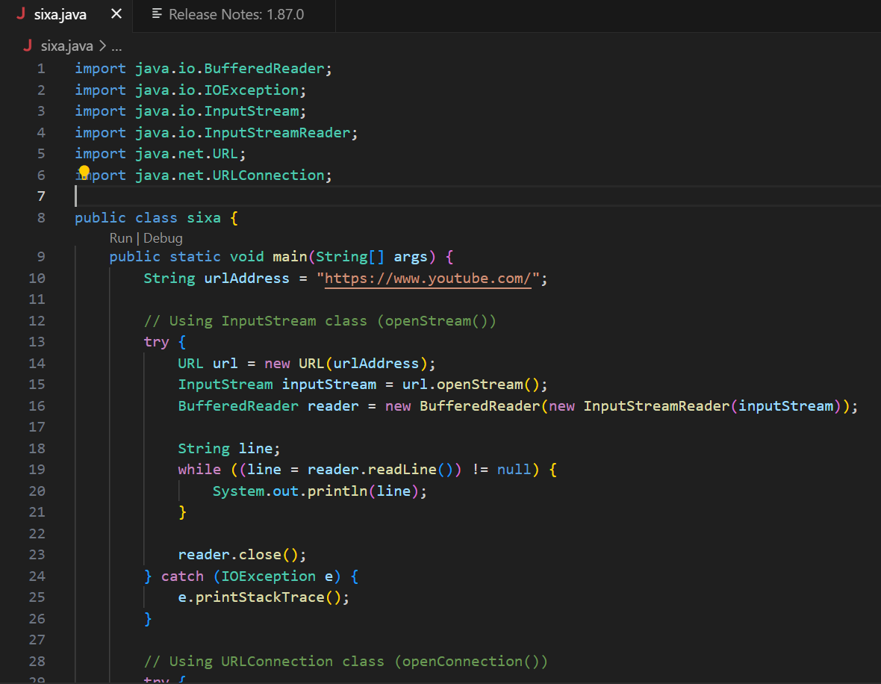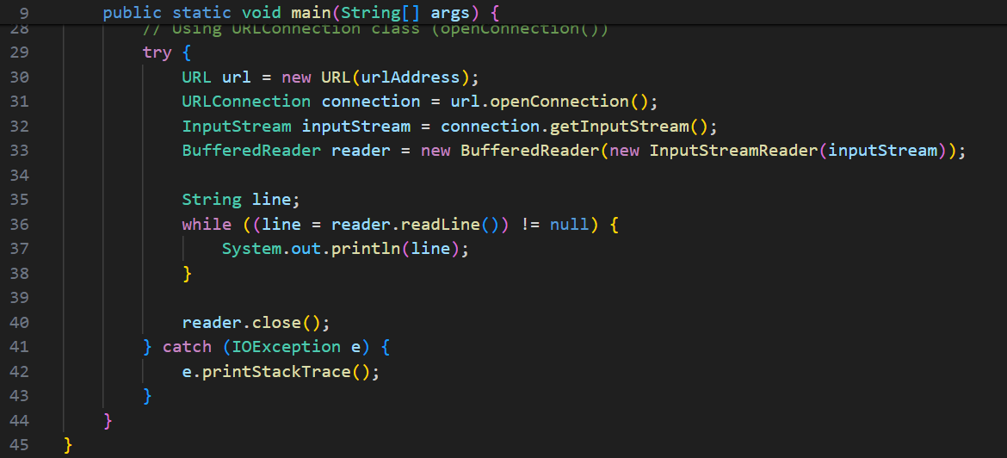

**OUTPUT-**

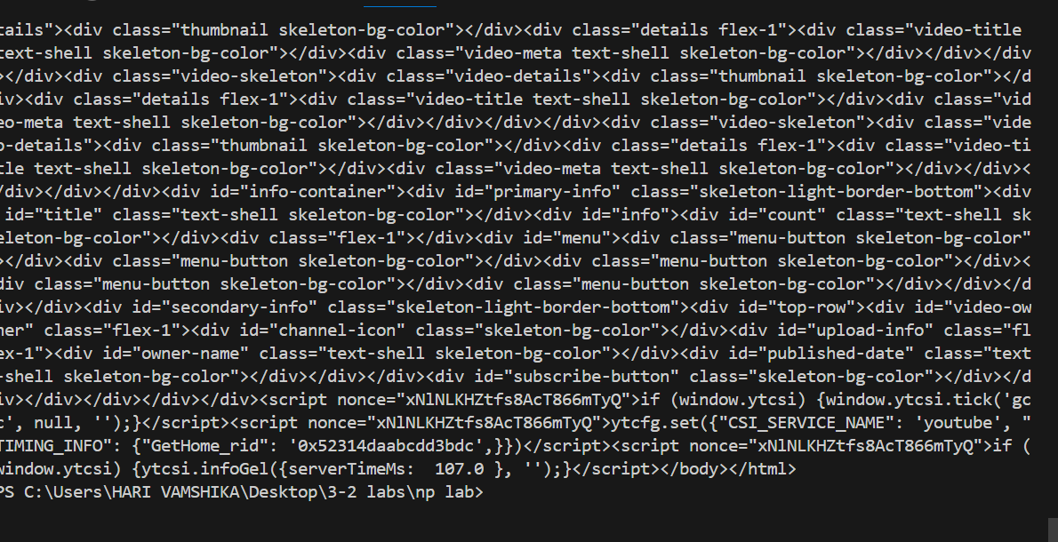

**B. you have been asked to develop connect to the url and set the following connection configurations,**

**Allow user interaction**

**Dont allow read operations**

**Allow Write operations**

**Disable the Chache**

**Set the connection timeout to 5000 sec**

**Set the read connection timeout to 2000sec**

**You have to print connection configuration settings before and after connection configuration.**

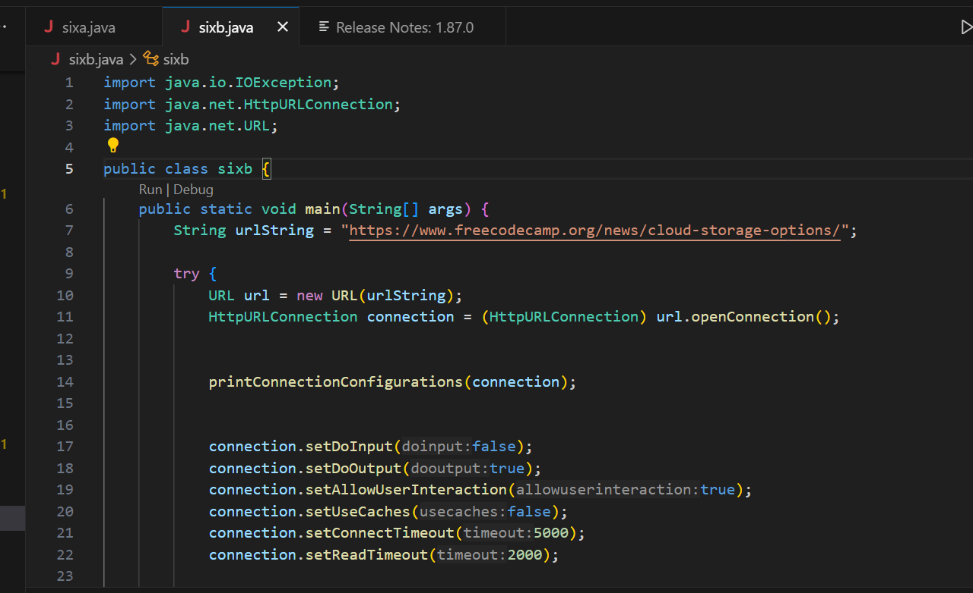

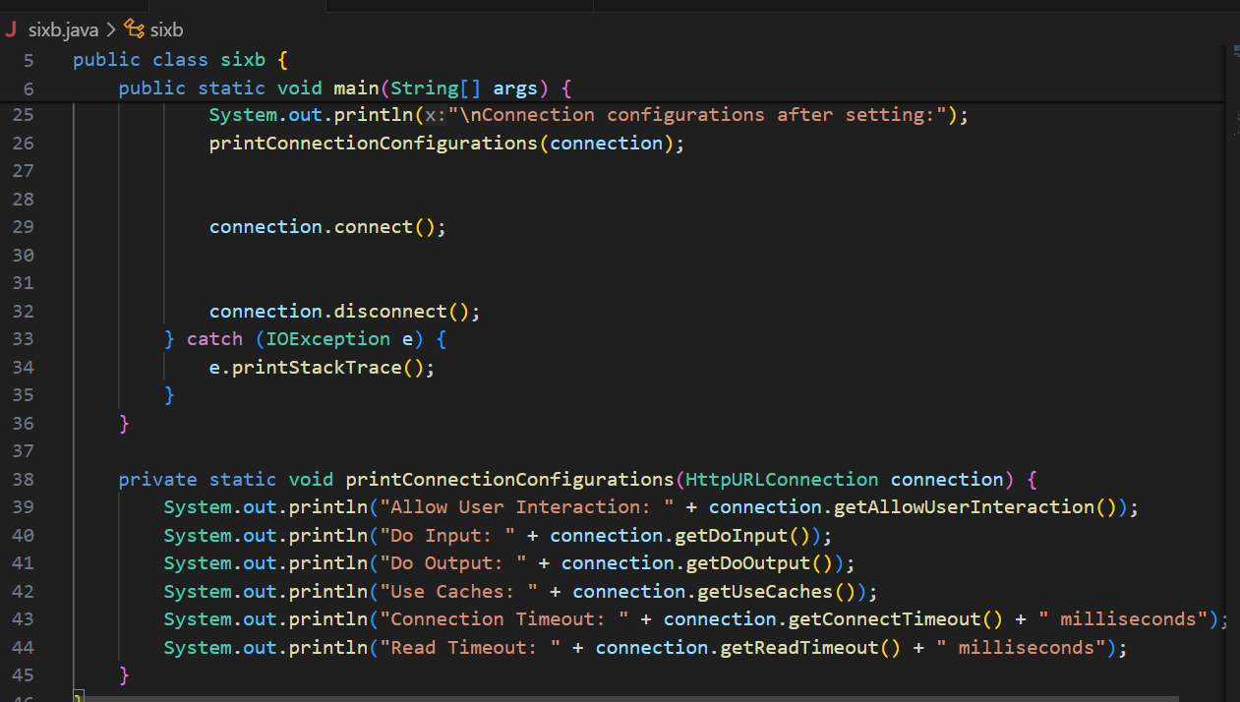

**OUTPUT-**

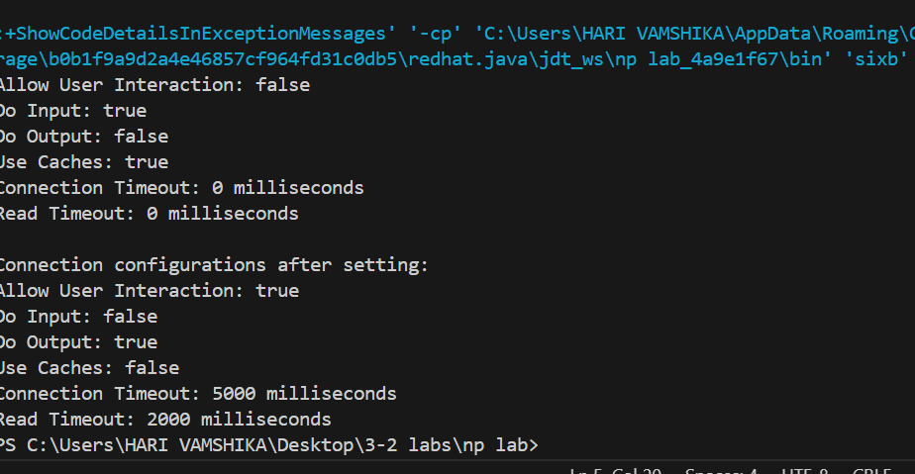

**2. Use the chache configuration class do the changes in the chache configurations then find the performance differs when you very the(nocache, nostorage, max-age, smax-age).**

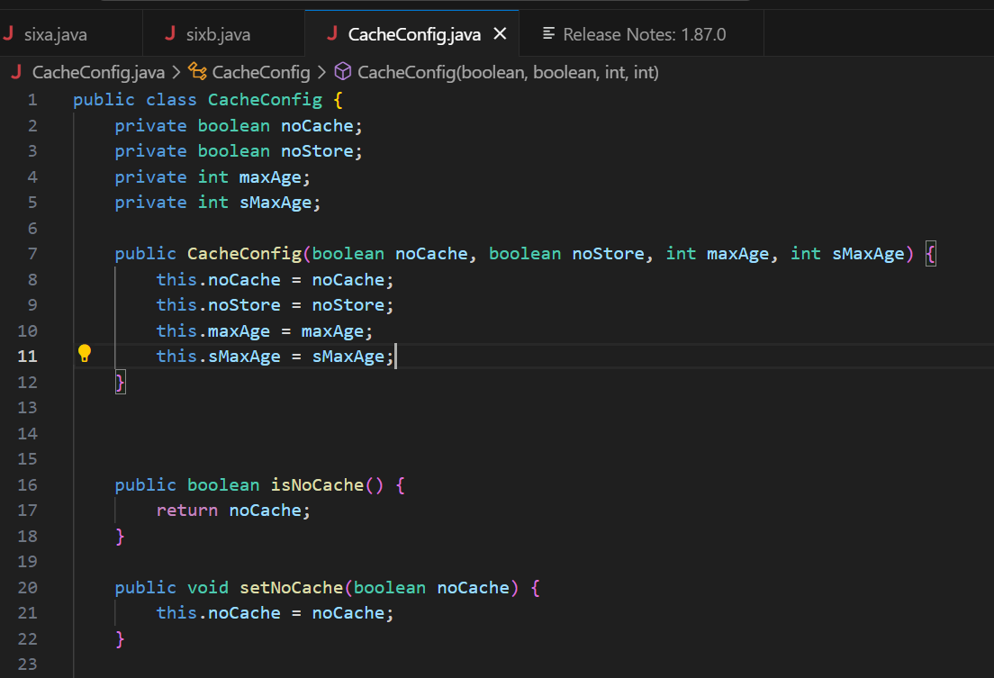

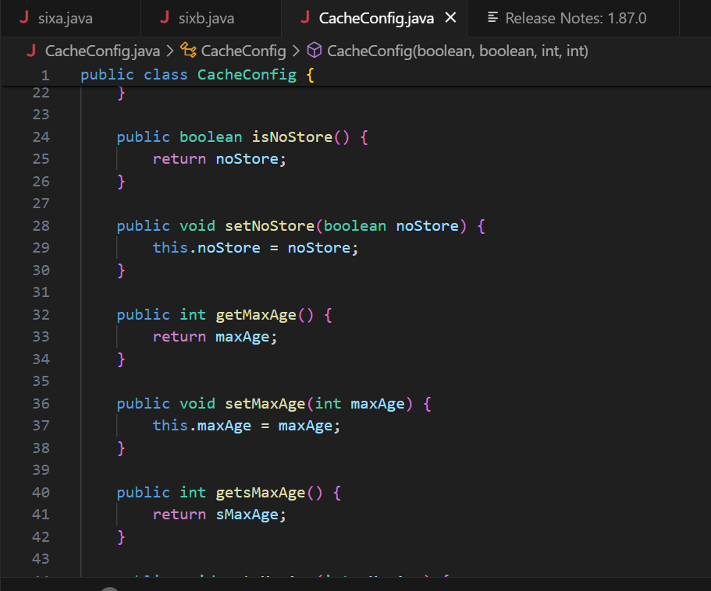

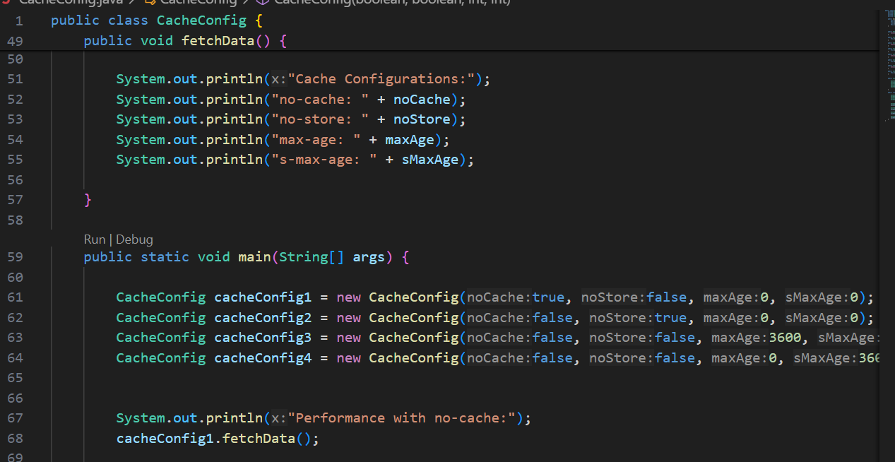

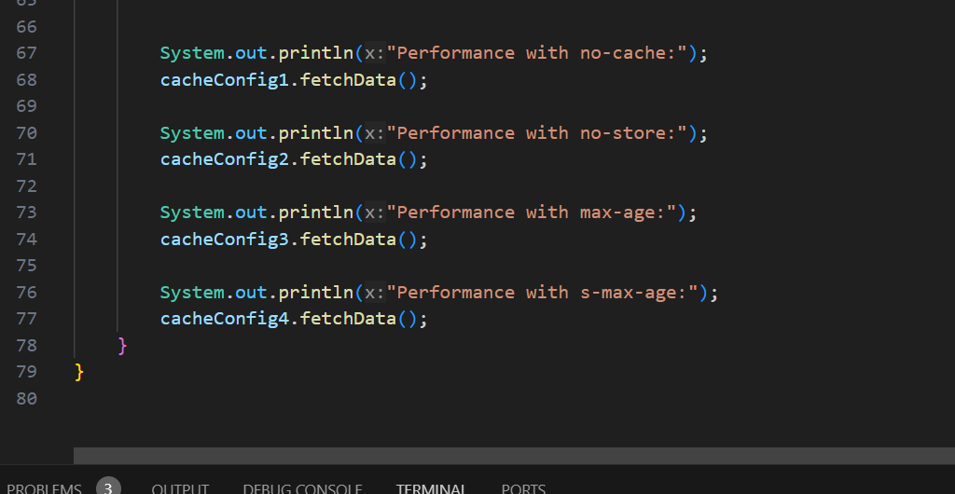

**OUTPUT-**

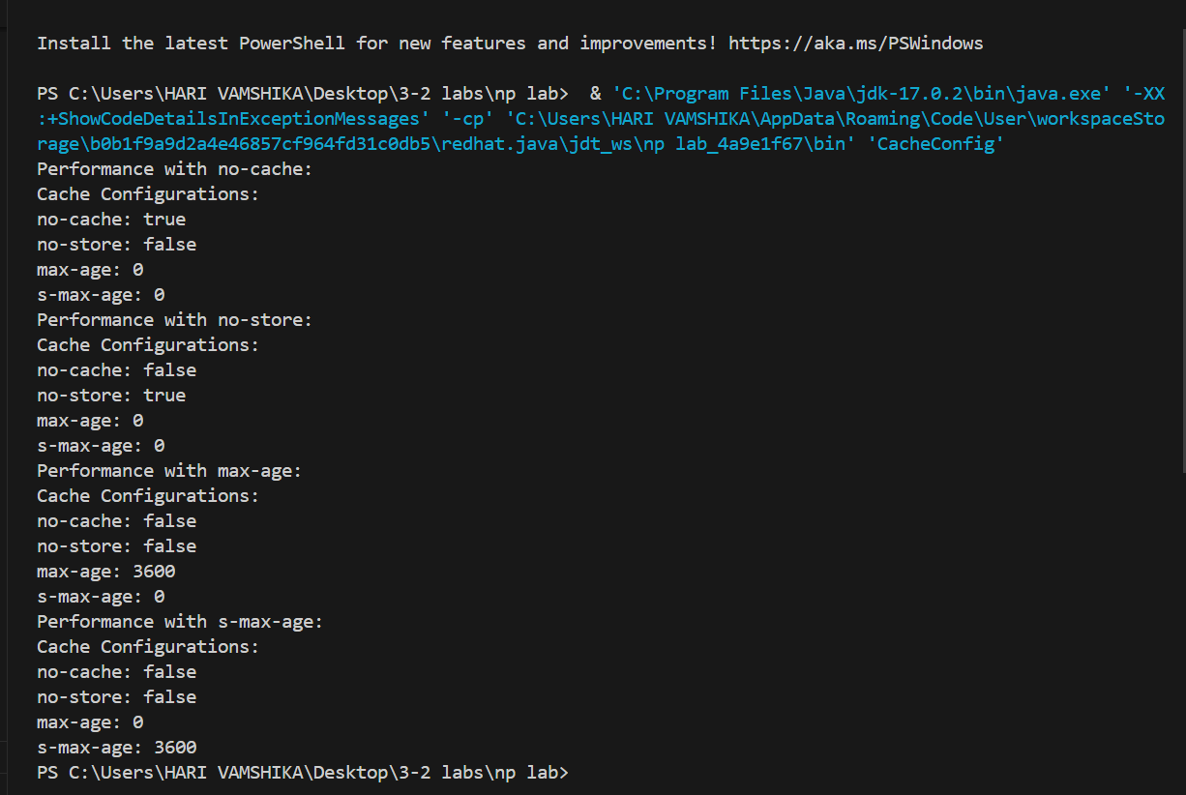

**LAB-7**

1. **find the difference between the URLconnection class and the HTTPURLConnection connection.**

`URLConnection` and `HttpURLConnection` are both classes in Java used for making HTTP connections, but `HttpURLConnection` is a subclass of `URLConnection` and provides additional functionality specific to HTTP connections.

1. **Scope**: `URLConnection` is a superclass that provides generic support for content retrieval over the network, supporting various protocols such as HTTP, HTTPS, FTP, etc. `HttpURLConnection` is a subclass specifically designed for HTTP connections.

2. **Functionality**: `HttpURLConnection` provides more specific methods and features tailored for HTTP connections, such as methods for setting request methods (GET, POST, PUT, etc.), setting request headers, handling response codes, and accessing response headers.

3. **Type**: While `URLConnection` is an abstract class, `HttpURLConnection` is a concrete class, meaning you can directly instantiate `HttpURLConnection` objects, but you cannot instantiate `URLConnection` directly.

4. **Protocol Support**: While both classes support HTTP connections, `HttpURLConnection` is optimized for HTTP and provides better support and control over HTTP-specific features.

In summary, `HttpURLConnection` is a specialized version of `URLConnection` tailored specifically for HTTP connections, providing additional features and control over HTTP-specific functionalities.

1. **explore all httpurlconnection class methods.**

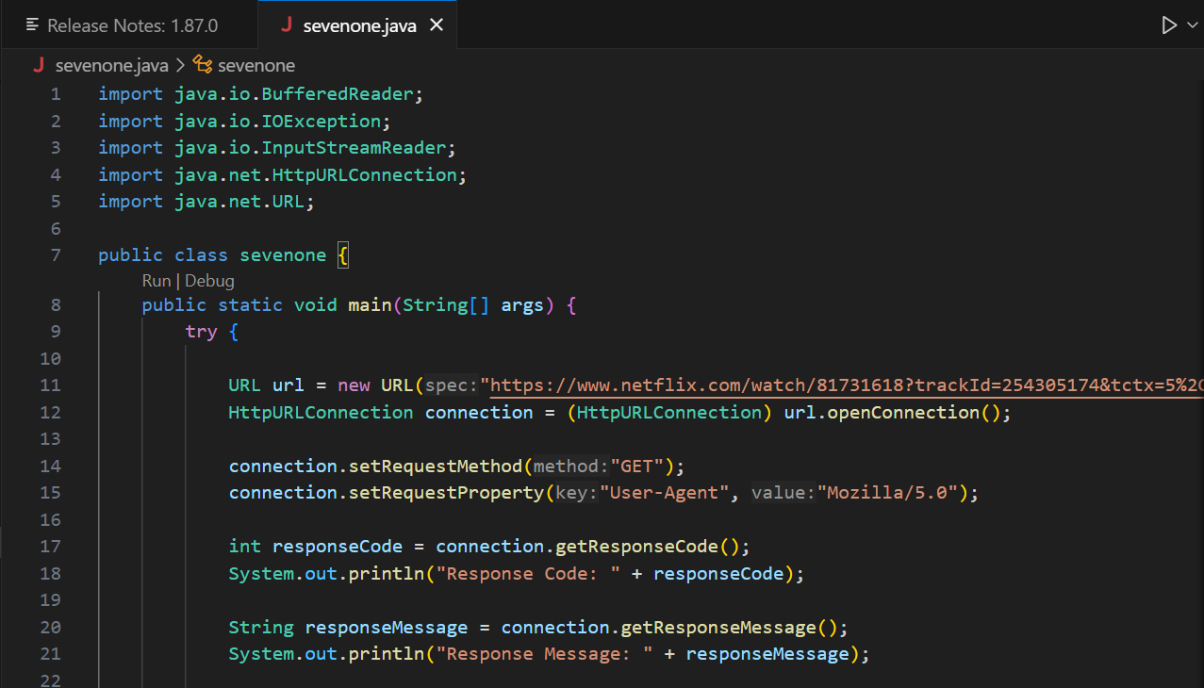

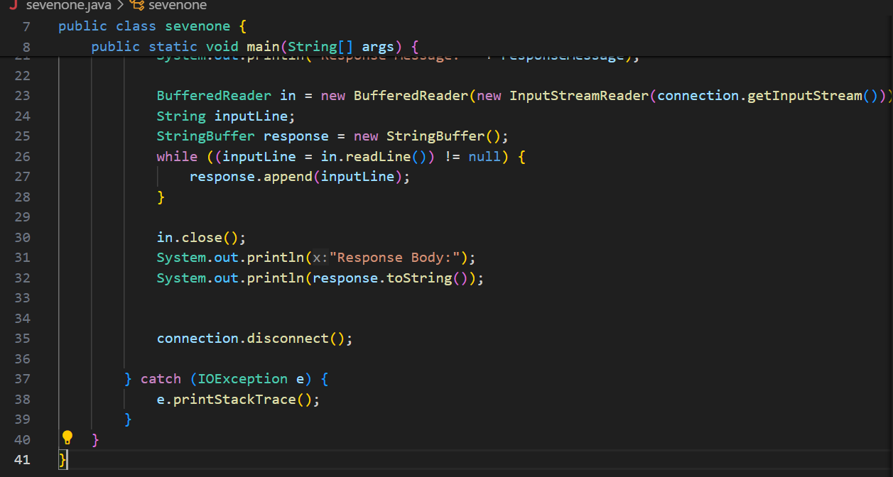

**OUTPUT-**

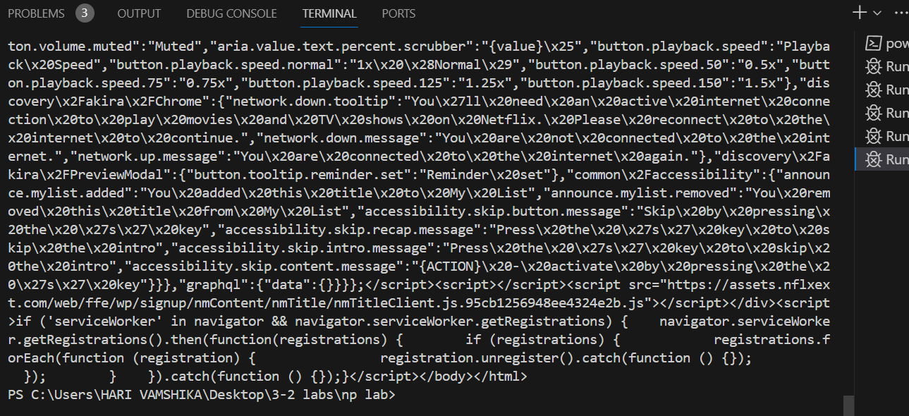

**Lab-8(09-03-204)**

**Implement the client and server echo java program.**

**SERVER-**

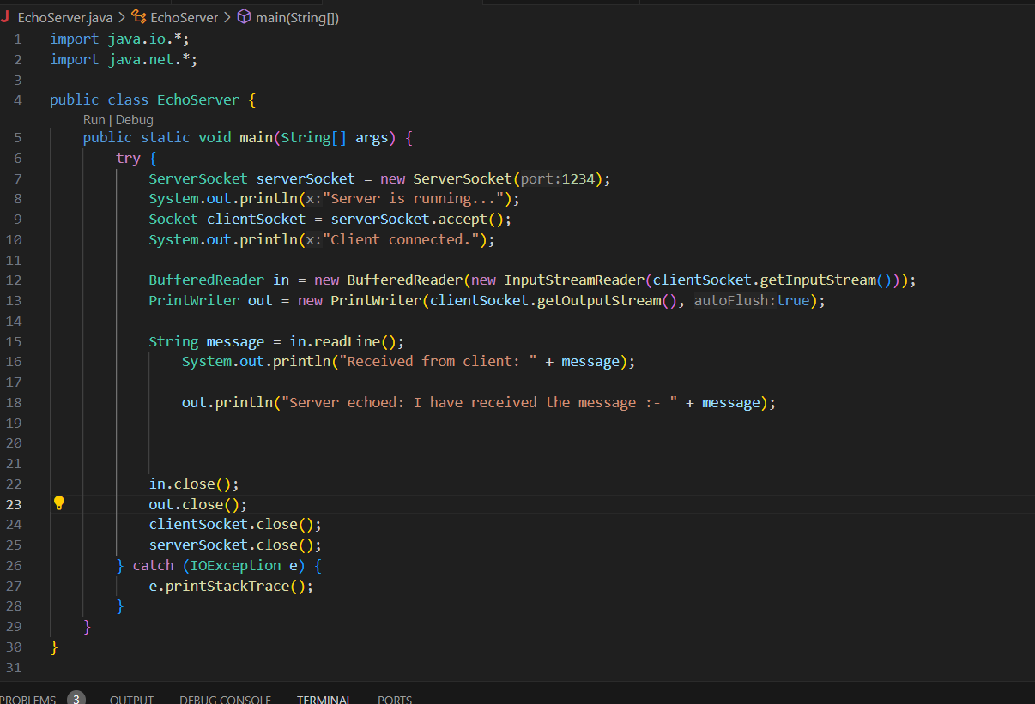

**CLIENT-**

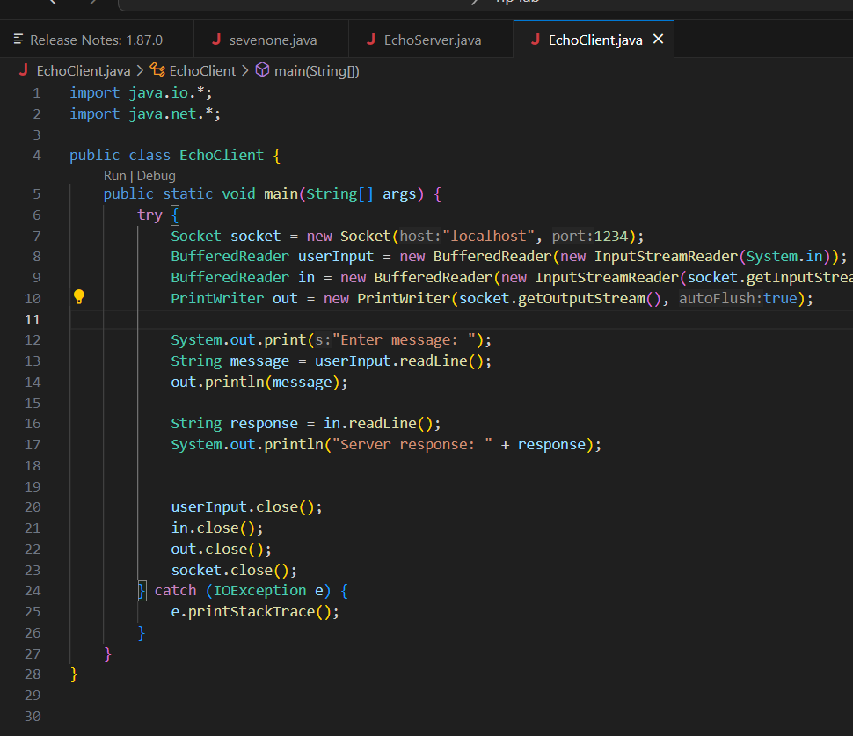

**OUTPUT-**

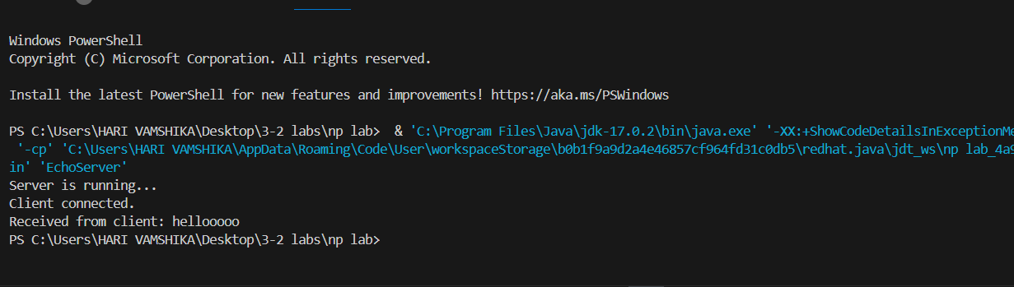

**Write a client program to send the last 500 characters data from a file to the server. Then write a Server program receives these 500 characters and replace the lowercase letter to uppercase letters then send it to the client.**

**CODE-**

**CLIENT –**

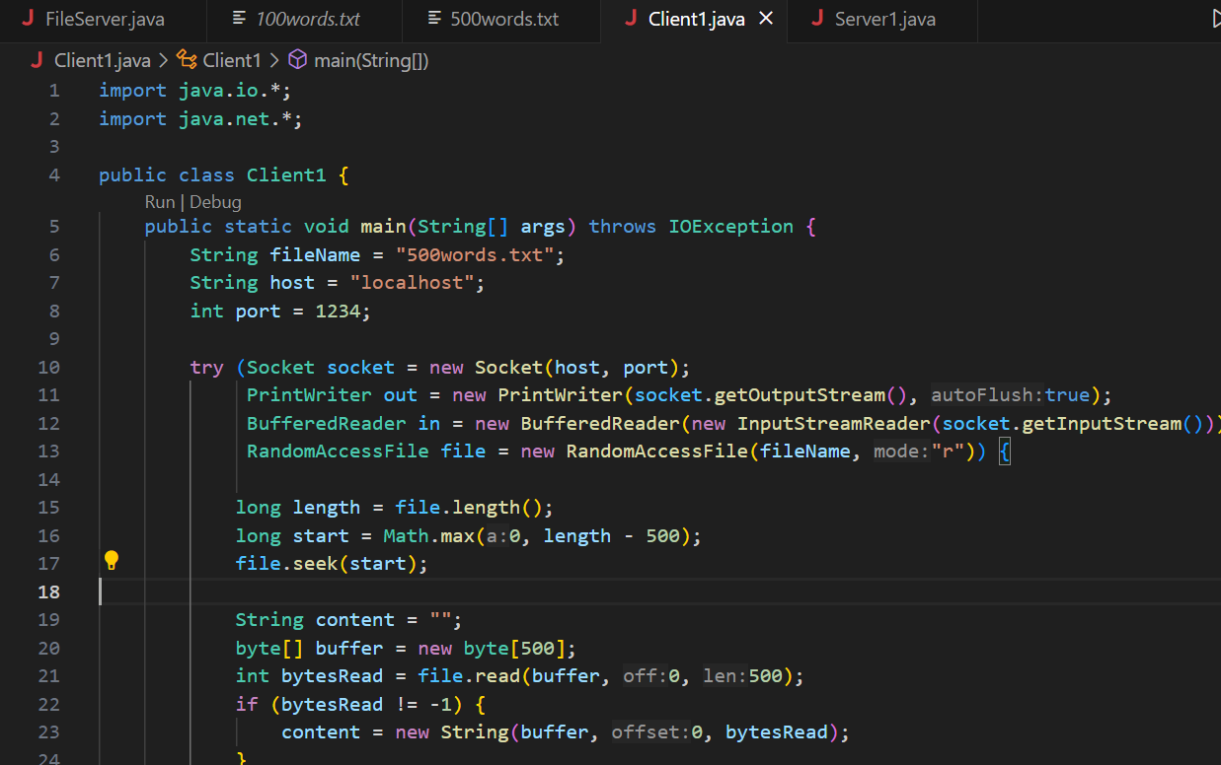

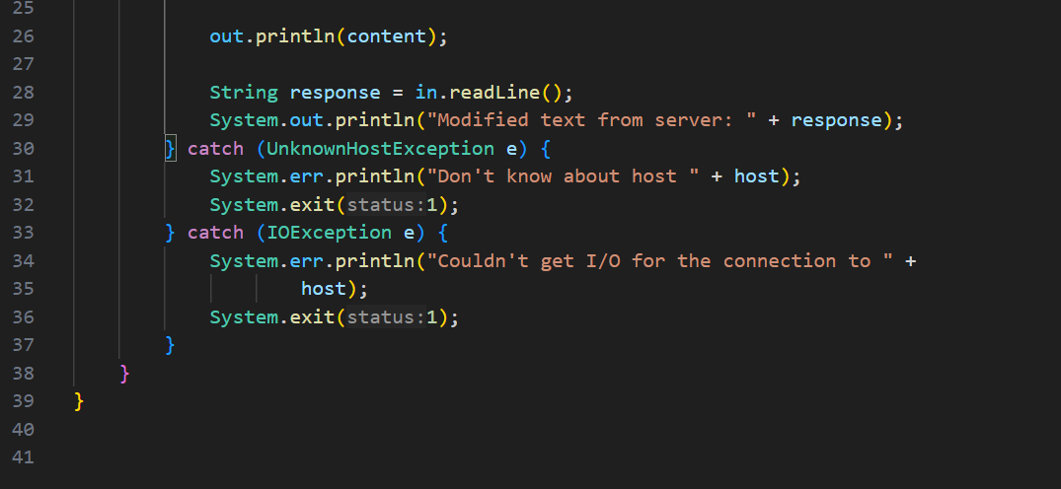

**SERVER –**

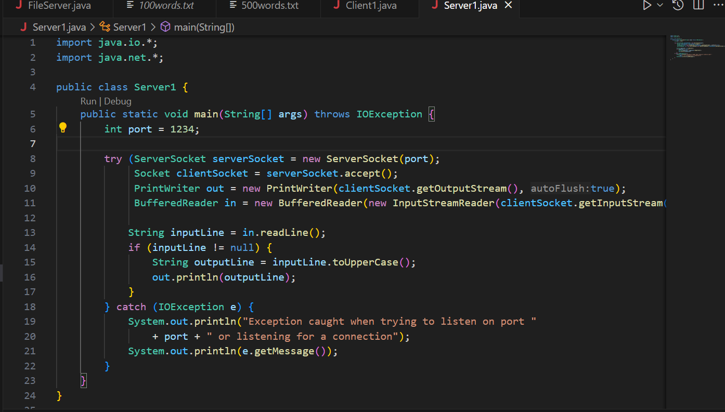

**OUTPUT-**

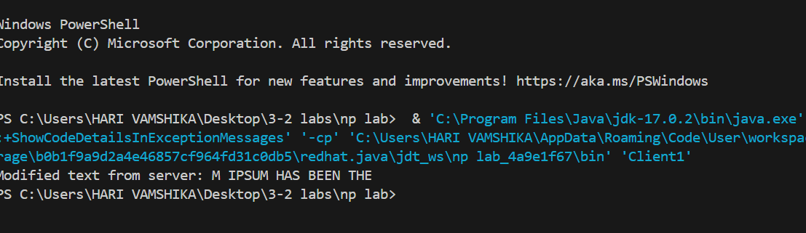

**Write the client and server programs, where two are more clients sends request to the server to get the time of the server as a response message for the client request.**

**CODE-**

**CLIENT 2-**

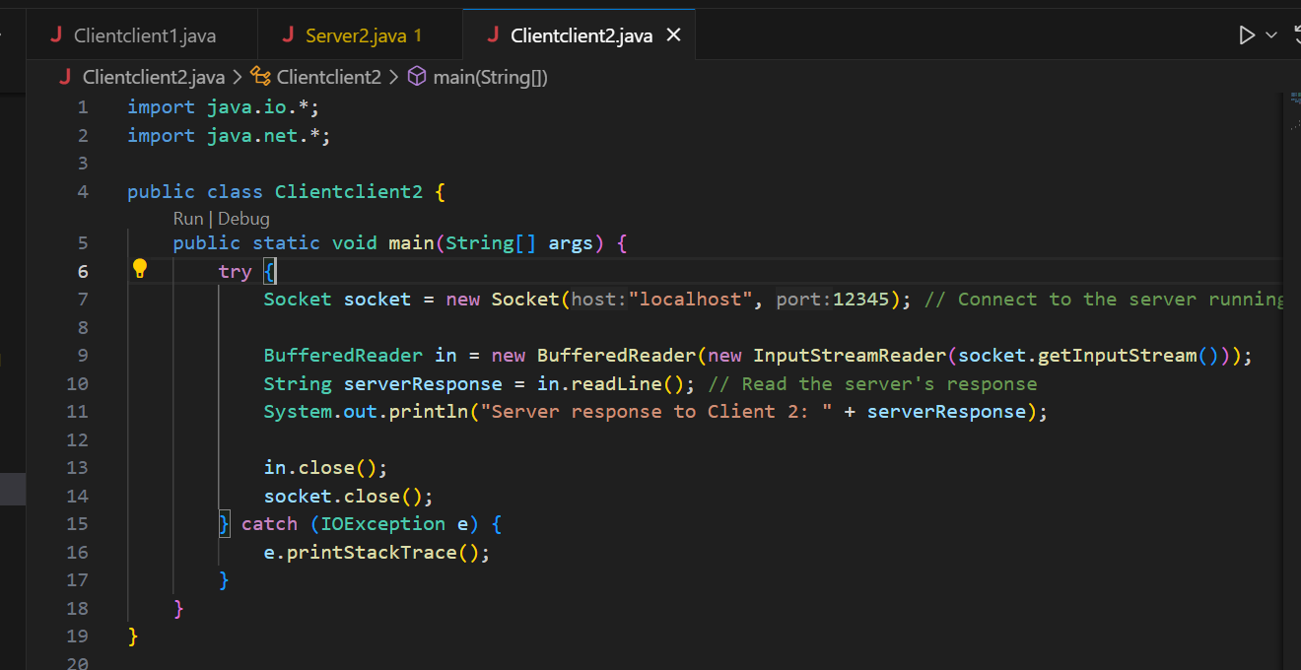

**CLIENT 1-**

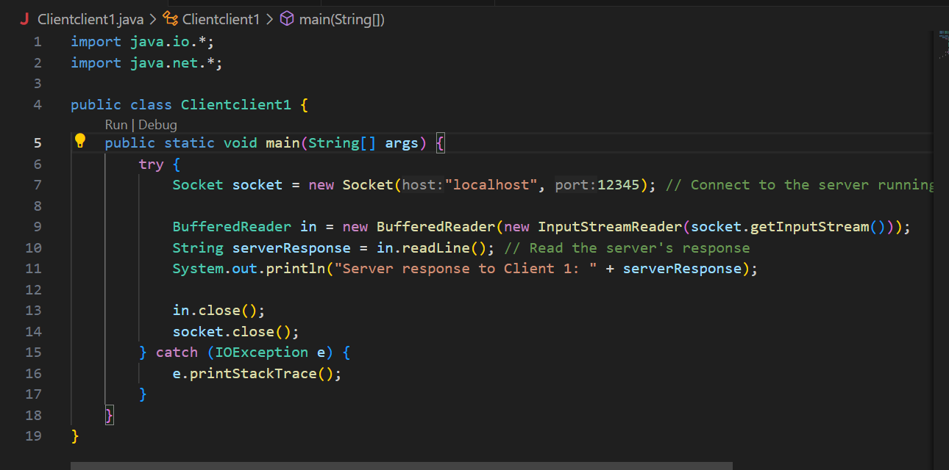

**SERVER-**

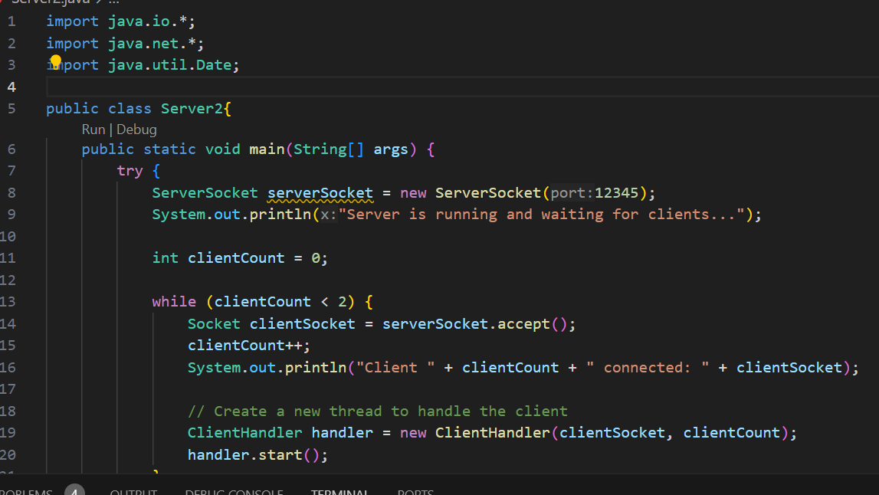

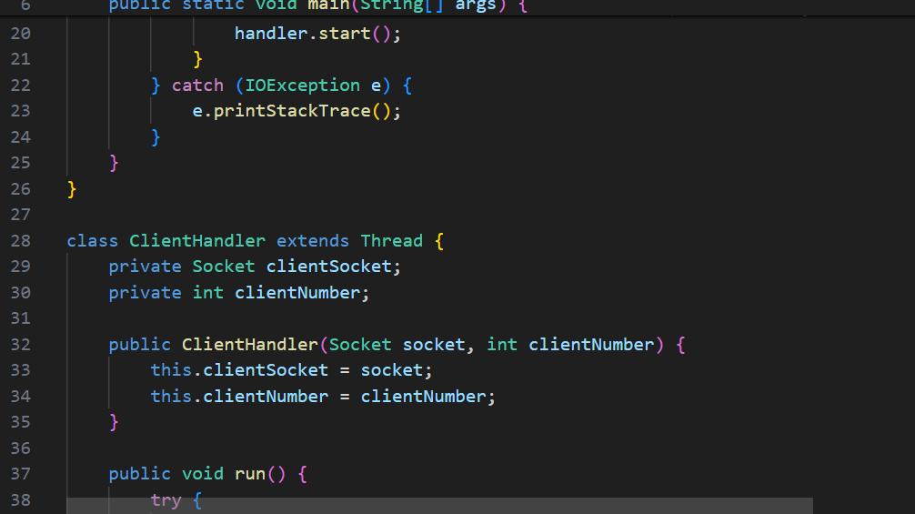

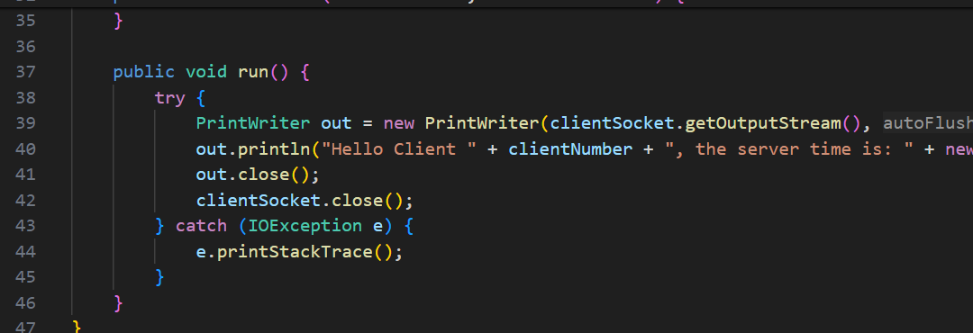

**OUTPUTS-**

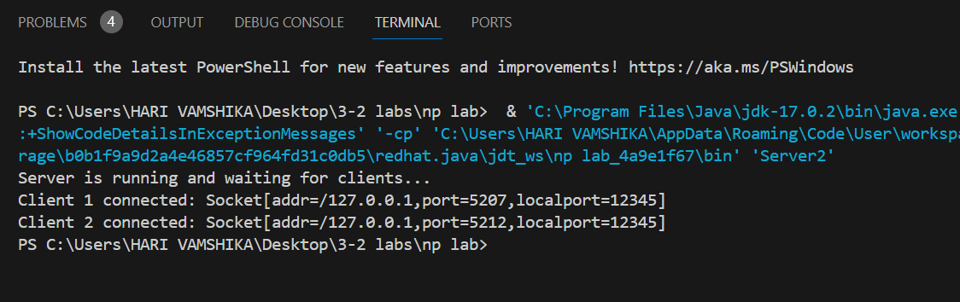

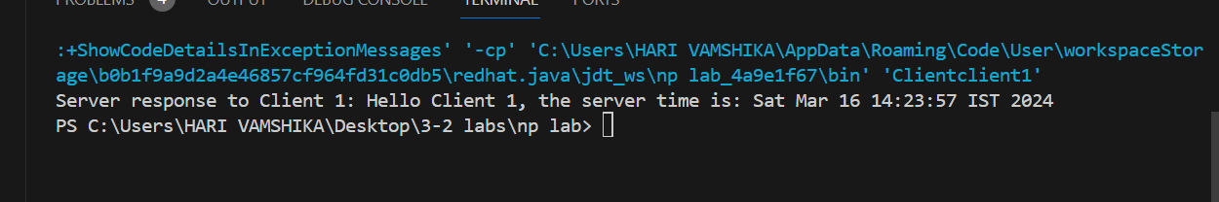

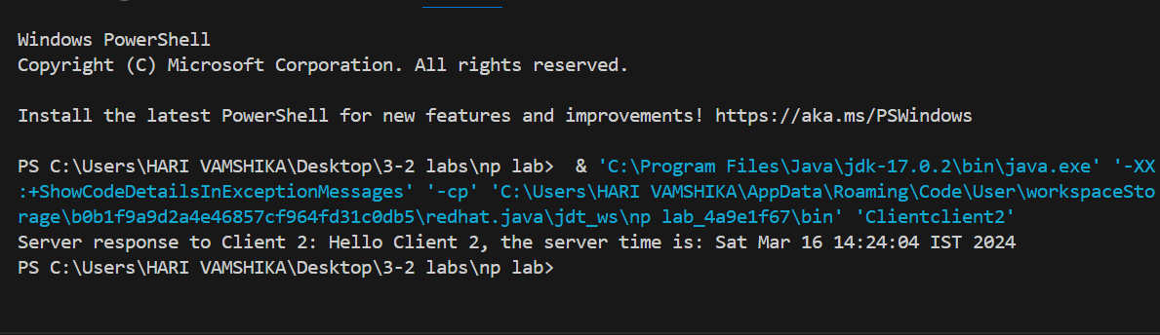

**Lab-9(09-03-2024)**

**Show the network connection permanence difference between socket without socket options and the with sockets options**

**•TCP_NODELAY**

**•SO_BINDADDR**

**• SO_TIMEOUT**

**•SO_LINGER**

**•SO_SNDBUF**

**•SO_RCVBUF**

**•SO_KEEPALIVE**

**OOBINLINE • IP_TOS**

**CODE-**

**SERVER-**

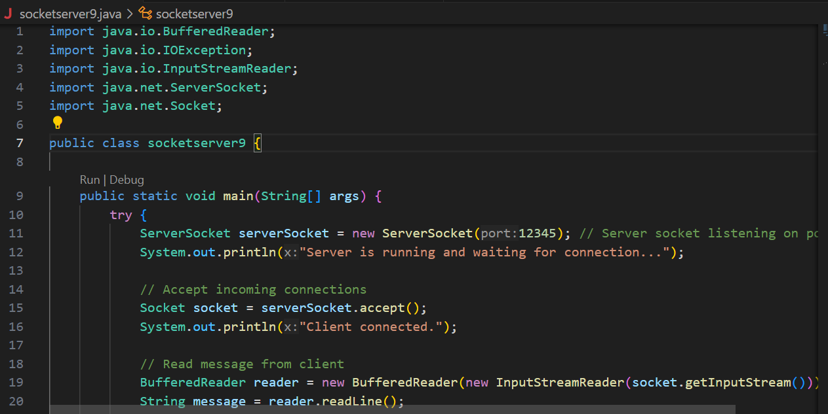

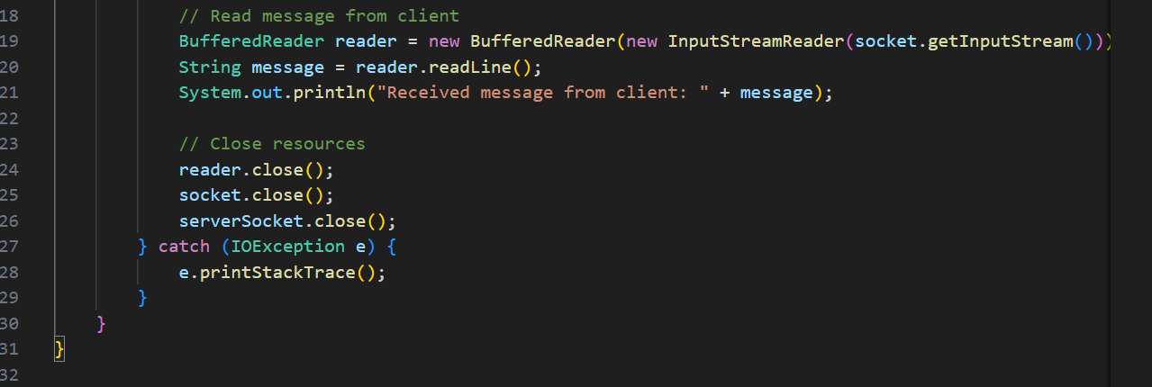

**CLIENT-**

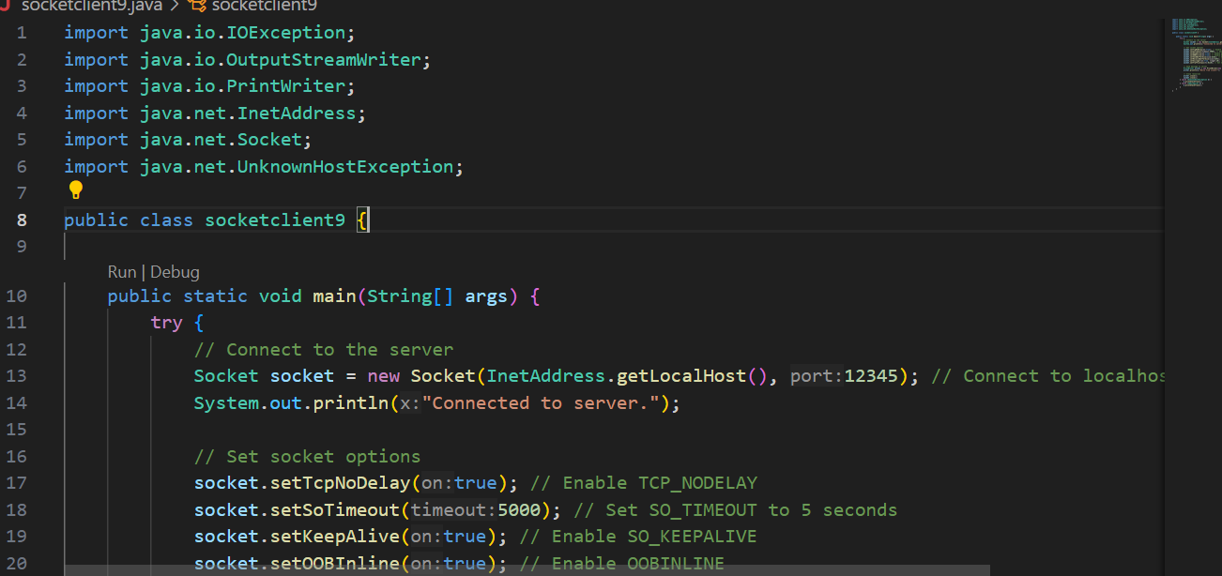

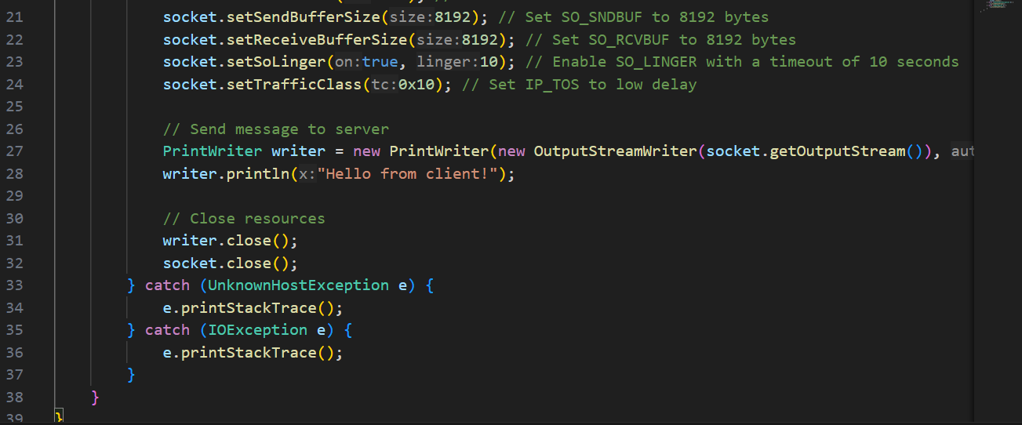

**OUTPUT-**

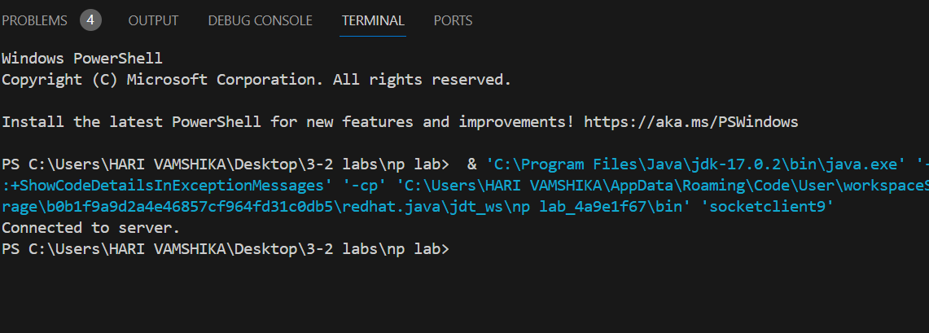

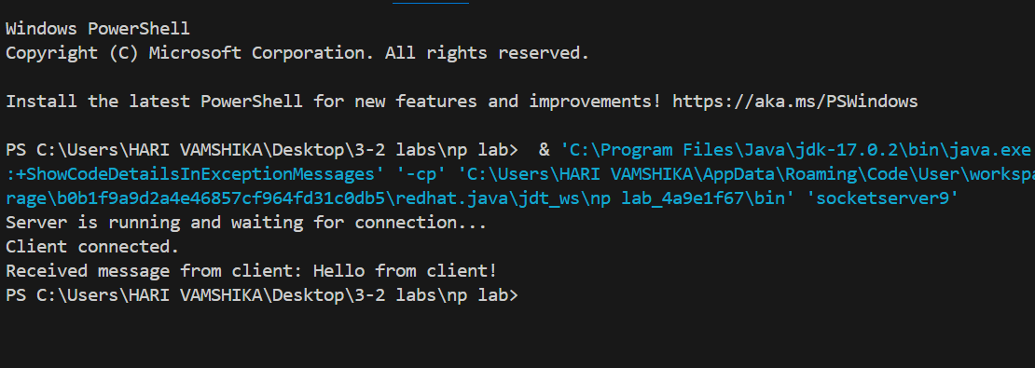

**LAB-11(6-4-2024)**

**Convert the lab 9 and 10 programs to secure socket programming.**

**CODE-**

**Server-**

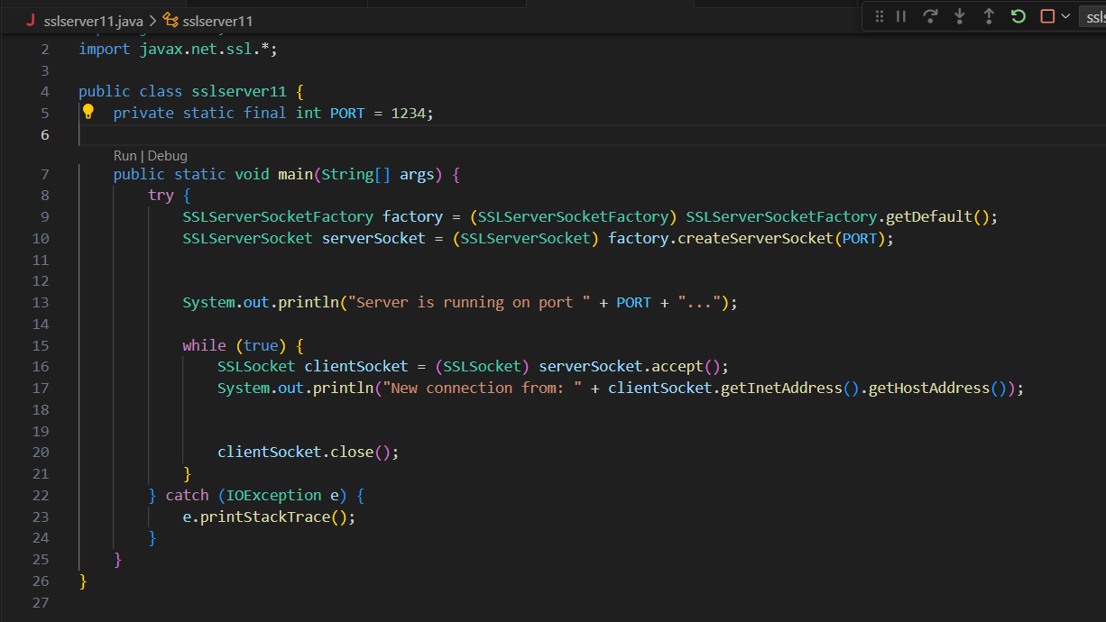

**Client-**

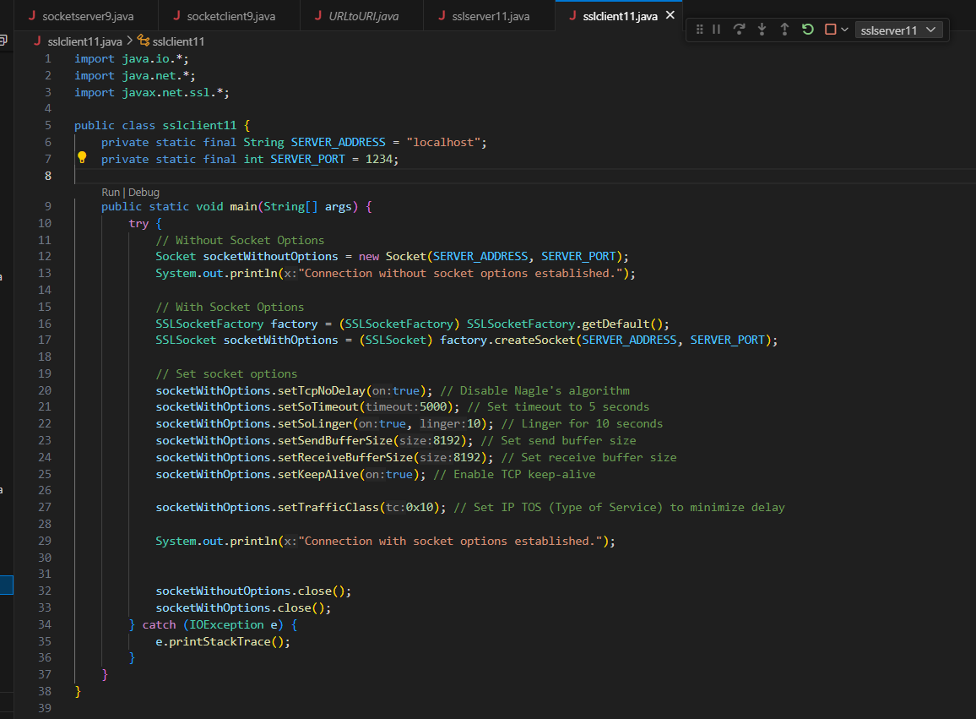

**OUTPUT-**

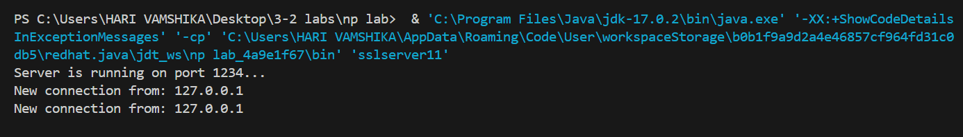

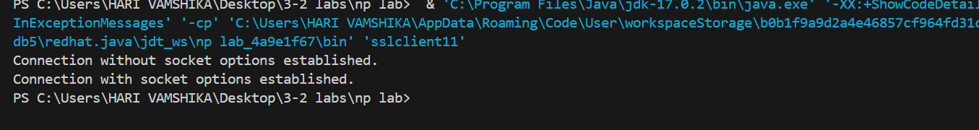

**LAB-12 (13-4-2024)**

**Find the all supported cipher suites in the client and server programs.**

**Enable the following cipher suites for secure client and server communication:**

**TLS_ECDH_ECDSA_WITH_AES_128_CBC_SHA256**

**• TLS_ECDH_RSA_WITH_AES_128_CBC_SHA256**

**• TLS_DHE_RSA_WITH_AES_128_CBC_SHA256**

**• TLS_DHE_DSS_WITH_AES_128_CBC_SHA256**

**• TLS_ECDHE_ECDSA_WITH_AES_128_CBC_SHA**

**• TLS_ECDHE_RSA_WITH_AES_128_CBC_SHA**

**• TLS_RSA_WITH_AES_128_CBC_SHA**

**Generate the ssl certificate using keytool using command line**